Lithuania
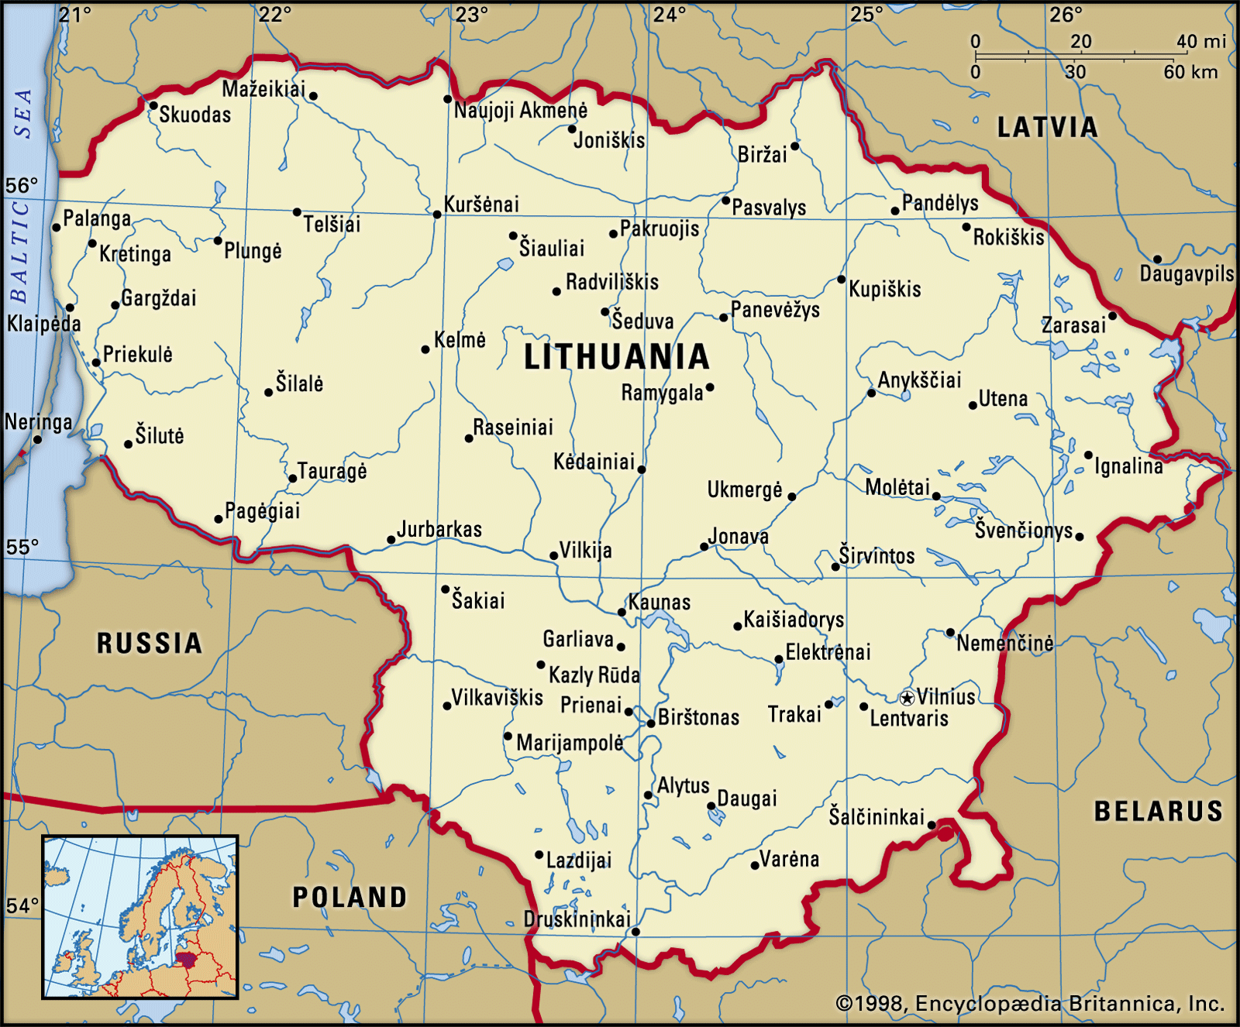
Chronology
bf.1203 Semi-legendary Grand Principality of Lithuania¹
(Magnus Ducatus Lituaniae/Lietuvos Didžioji
Kunigaikštystė), ruled by a Grand Prince of
Lithuania.
c.1236 Unification of the state of Lithuania.
17 Jul 1251 Lithuania recognized as a state by Pope Innocent IV.
5 Jul 1253 - 12 Sep 1263 Grand Prince Mindaugas adopts style of Lithuanian
and Russian King, etc.
2 Feb 1386 By marriage with the Polish regnant Queen
(properly [female] king) Jadwiga, the Grand
Prince Jogaila/Jagiełło becomes Polish king
(Władysław II after baptism)(crowned 4 Mar 1386),
and his successors frequently occupy both thrones
18 Jan 1401 - 1 Jun 1434 Jogaila oversees the successive grand princes of
Lithuania with the style "Supreme Prince of
Lithuania (supremus dux Lithuanie)"
1 Jul 1569 Accord of Lublin, colloquially known as "Union of
Lublin", joining Poland and Lithuania
officially, but not constitutionally, into
United Commonwealth of the Two Nations, in
short, The Commonwealth (Rzeczpospolita).
6 Jul 1572 Last hereditary Polish king dies. The Kingship
becomes elective; election as Polish King and
Grand Prince of Lithuania is carried out
jointly, but conduct of interregnum is
separate.
1691 - 29 Sep 1793 Lordships of Tauroggen and Serrey ceded to Prussia.
May 1702 - 1709 Occupied by Sweden (Vilnius, the capital,
is occupied by Russia 1705 - Mar 1706).
5 Aug 1772 First partition of Poland-Lithuania by Russia,
Prussia, and Austria. Lithuanian voivodeships of
Vitebsk, Polotsk and Mstislavl annexed by Russia.
3 May 1791 First and only Constitution, giving formal
sanction to the union with Poland, etc.
23 Jan 1793 Second partition by Russia and Prussia. Lithuanian
voivodeships of Minsk, Brest-Litovsk and parts of
Vilnius annexed by Russia.
12 Aug 1794 Occupied by Russia.
30 Oct 1794 - 12 Dec 1796 Divided into the Vilna governorate (Vilenskaya
guberniya) and Slonim governorate (Slonimskaya
guberniya) of Russia.
7 Jan 1795 Third Partition of the Polish-Lithuanian
Commonwealth: the Grand Principality of
Lithuania is incorporated into Russia, the
Emperor adopting the additional style of
"Grand Prince of Lithuania."
12 Dec 1796 Lithuania governorate (Litovksaya guberniya).
9 Sep 1801 Re-divided into Vilna governorate and
Grodno governorate (Grodnenskaya guberniya).
28 Jun 1812 - 10 Dec 1812 Occupied by France (on 1 Jul 1812, a Commission of
the Provisional Government of Lithuania
[Commission du gouvernement provisoire de la
Lithuanie/Komisja Tymczasowego Rządu Litewskiego]
is created by order of French Emperor Napoléon -
composed of the departments of Vilna (Wilna),
Grodno, Minsk and Białystok (Bialystock). However,
the Grand Principality of Lithuania, to
eventually be under a joint Franco-Saxon
protectorate, is not restored).
10 Dec 1812 Russian forces re-occupy Vilna (Vilnius).
26 Mar 1831 - 9 Jul 1831 Russian rule partially interrupted by rebellion in
conjunction with the "First Insurrection" in
Poland, however the rebels fail to capture
Wilna (Vilnius) and Kowno (Kaunas).
18 Jun 1840 - 30 Jun 1912 Vilna governorate (Vilenskaya guberniya) part of
the Northwestern Region (Severozapadny kray)
(incl. Minsk, Grodno, Vitebsk, and later Kovno).
1 Jul 1843 Kovno governorate (Kovenskaya Guberniya) formed
from the western part of Vilna governorate.
1 Feb 1863 - 10 Feb 1864 Russian rule interrupted by rebellion in
conjunction with the "Second Insurrection" in
Poland.
22 May 1864 - 24 Apr 1904 Lithuanian and Polish printed in Latin alphabet
are banned.
1870 - 1912 Vilna, Kovno and Grodno guberniyas constituted as
Government-general of Lithuania (seat in Vilna).
24 Jan 1905 - Dec 1905 Local rebellions part of Russian Revolution of 1905.
6 Dec 1905 Lithuanian Assembly (Seimas), chaired by Jonas
Basanavičius (b. 1851 - d. 1927), demands
provincial autonomy for Lithuania (not effected).
Apr 1915 - 18 Sep 1915 Lithuania (Russian provinces of Kovno and
Vilna) gradually occupied by Germany (18 Aug
1915 city of Kaunas, 18 Sep 1915 city of
Vilnius). German administrations for
Administrative Region of Lithuania and
Administrative Region of Vilnius established;
subordinated to commander of the Eastern front.
18-22 Jan 1917 A Congress demands independence for Lithuania
(as planned by the German administration).
4 Mar 1917 Both German military administrations united into
central Military Administration of Lithuania
seated in Vilnius.
18 Sep 1917 Lithuanian Council (Lietuvos Taryba) formed.
11 Dec 1917 Declaration of the re-establishment of Lithuanian
independence by Lithuanian National Council.
16 Feb 1918 Full independence of state of Lithuania declared
by the Lithuanian Council; declaration prohibited
by German occupation authorities.
3 Mar 1918 In the Treaty of Brest-Litovsk (Brześć Litewski)
Lithuania is "no longer subject to Russian
sovereignty", but Germany to "determine the
future status of the territories in agreement
with population".
23 Mar 1918 Independence recognized by Germany (Lithuanian
State [Lietuvos Valstybė]; Lithuania [Lietuva] and
Republic of Lithuania [Lietuvos Respublika] are
also in official use).
4 Jun 1918 Prospective king invited (elected on 13 Jul 1918,
who withdraws on 2 Nov 1918).
11 Nov 1918 In the Armistice at Compiègne the Treaty of
Brest-Litovsk is declared void and the German
troops are be withdrawn (fixed time not given).
29 Nov 1918 The Principal Allied and Associated Powers
recognize de facto independence of Lithuania.
5 Jan 1919 - 27 Feb 1919 Lithuanian Socialist Conciliar ("Soviet") Republic,
in opposition to Republic of Lithuania (see below).
27 Feb 1919 - 1 Sep 1919 Part of Socialist Soviet Republic of Lithuania
and Belorussia ("Litbel") under Russian pressure;
in opposition to Republic of Lithuania.
31 Dec 1918 - 25 Aug 1920 Polish and Soviet Russian troops occupy Vilnius;
capital of Lithuania is moved to Kaunas.
12 Jul 1920 Independence recognized by Russia.
9 Oct 1920 Polish irregular occupation of Vilnius (from 12 Oct 1920 Central Lithuania).
18 Apr 1922 Vilnius annexed by Poland.
20 Dec 1922 Independence de jure recognized by the Principal
Allied and Associated Powers.
23 Jan 1923 - 22 Mar 1939 Lithuania annexes Memel (renamed Klaipėda).
23 Mar 1939 - 28 Jan 1945 Germany re-annexes Memel.
28 Oct 1939 Vilnius restored to Lithuania by Soviet Union.
15 Jun 1940 Lithuania occupied by the Soviet Union.
21 Jul 1940 Lithuanian Soviet Socialist Republic.
3 Aug 1940 Incorporation into Soviet Union (not
internationally recognized).
22 Jun 1941 Germany invasion begins.
23 Jun 1941 - 5 Aug 1941 Independence of the Republic of Lithuania
(Lietuvos Respublika) declared in Kaunas,
provisional government (gradually restricted)
allowed in liberated areas and in the German rear
until 5 Aug 1941.
24 Jun 1941 Kaunas and Vilnius occupied by Germany (until 25
Jul 1941 [Vilnius to 1 Aug 1941] remains under
military administration).
25 Jul 1941 - 13 Jul 1944 Lithuania is made a General District
(Generalbezirk Litauen), within the
Reichskommissariat of Ostland (see under Latvia).
13 Jul 1944 - 28 Jan 1945 Lithuania re-occupied by the Soviet Union
(Vilnius on 13 Jul 1944, Kaunas on 1 Aug 1944,
and Memel on 28 Jan 1945).
18 May 1989 Declaration of state sovereignty.
11 Mar 1990 Independence declared (Republic of Lithuania
[Lietuvos Respublika]; use of Lithuanian [Lietuva]
as alternate style approved).
9 Feb 1991 Referendum supports independence with 93.2% of vote.
6 Sep 1991 Independence recognized by Soviet Union.
1 May 2004 Part of European Union.
Note: After 1572, no Lithuanian held the title of Grand Prince. Dominance by Poland led to increased Polonization of the country and in 1698 Polish was declared the official state language of the entire Commonwealth replacing Lithuanian and Belarusian in Lithuania. The cultural, political, and economic discourse of the nation was Polish, and Lithuanian and Belarusian were relegated to languages spoken by the illiterate peasants of the eastern regions of the Commonwealth. This situation persisted under Russian rule, when Russian was the official language, until 1905 with the rebirth of the Lithuanian language (which had begun in 1863) which was again legally allowed inside Lithuania.
Grand Princes² (Lithuanian with Polish names in parentheses)
11.. - 1213 Daugirutis (d. 1213)
(= Dangerutis, Dangeruthe)
1213 - 12.. Živinbudas
12.. - 12.. Daujotas
12.. - 12.. Dausprungas (= Dovsprunk) (d. af.1219)
123. - 6 Jul 1253 Mindaugas (= Mindovg, Mindowe) (b. c.1203 - d. 1263)
King
6 Jul 1253 - 12 Sep 1263 Mindaugas (I) (Mendog) (s.a.)
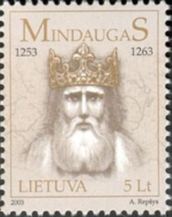 |  |  | 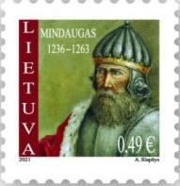
Grand Princes² (Lithuanian with Polish names in parentheses)
1263 - 1264 Treniota (Troniata) (b. c.1210 - d. 1264)
1264 - 1267 Vaišelga (Wojsiełk) (= Vaišvilkas) (b. 123. - d. 1268)
1267 - c.1269 Švarnas (Szwarno) (b. c.1236 - d. c.1269)
(= Svarnas, Shvarno, Shkvarno)
c.1269 - c.1282 Traidenis (Trojden) (b. 122. - d. c.1282)
c.1282 - c.1290 Butigeidis (Butygejd) (b. 124. - d. c.1290)
c.1290 - c.1294 Butvydas (Pukuwer) (b. 124. - d. c.1294)
c.1294 - 1316 Vytenis (Witenes) (b. 127. - d. 1316?)
1316 - Dec? 1341 Gediminas (Giedymin) (b. c.1275 - d. 1341)
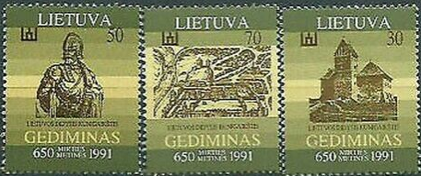
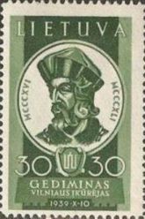 |  |  | 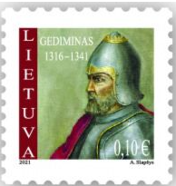
Dec? 1341 - Feb? 1345 Jaunutis (Jawnut) (b. 1301 - d. af.1366)
Feb? 1345 - 2 May 1377 Algirdas (Olgierd) (b. c.1296 - d. 1377)
- jointly with -
Feb? 1345 - 2 May 1377 Kęstutis (Kiejstut) (1st time) (b. c.1297 - d. 1382)
2 May 1377 - 10 Aug 1381 Jogaila (Jagiełło)(1st time) (b. c.1351 - d. 1434)
- jointly with -
2 May 1377 - 3 Aug 1382 Kęstutis (2nd time) (s.a.)
3 Aug 1382 - 5 Aug 1392 Jogaila (2nd time) (s.a.)
(from 15 Feb 1386 Vladislovas)
(from 18 Feb 1386, King of Poland Władysław II)
(supremus dux of Lithuaniae to 1 Jun 1434)
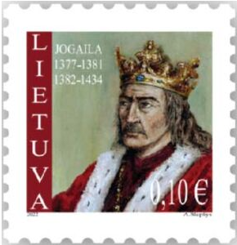
Apr 1387 - 5 Aug 1392 Skirgaila (Skirgiełło) (b. c.1353 - d. 1397)
(governor of Lithuania)
30 Jan 1384 - 27 Oct 1430 Aleksandras (= Vytautas) (b. 134. - d. 1430)
(Aleksandr [= Vitovt])
(in rebellion to 5 Aug 1392)
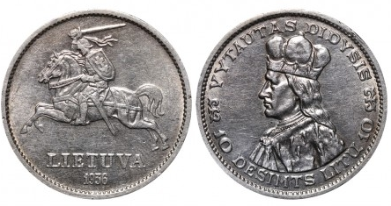
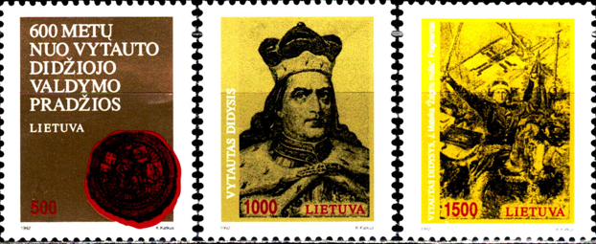
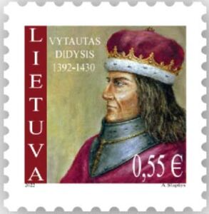 |  |  | 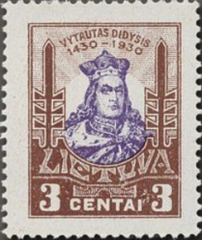
27 Oct 1430 - 7 Nov 1430 Vladislovas (= Jogaila) (3rd time) (s.a.)
(Władysław II Jagiełło)
(supremus dux Lithuaniae)
7 Nov 1430 - 1 Sep 1432 Boleslovas (Bolesław) (b. 137. - d. 1452)
(in rebellion to 1 Sep 1435)
1 Sep 1432 - 20 Mar 1440 Žygimantas I Kęstutaitis (b. c.1365 - d. 1440)
(Zygmunt I Kiejstutowicz)
(officially recognized by King
and Polish Royal Council from 15 Oct 1432)
20 Mar 1440 - 29 Jun 1440 Council of State
- Jonas Daugirdas (b. c.1392 - d. 1443)
(Jan Dowgird)
- Pacas Ginvilavičius
- Petras Montigerdavicius (d. c.1497)
(Piotr Janowicz Montygerdowicz)
(grand marshal)
- Radvila Astikaitis (b. 1384 - d. 1477)
(Radziwiłł Ościkowicz)
29 Jun 1440 - 7 Jun 1492 Kazimieras IV "Jogailaitis" (b. 1427 - d. 1492)
(from 25 Jun 1447 also King of Poland Kazimierz III)
7 Jun 1492 - 30 Jul 1492 Council of State
- Mikalojus Radvilavičius (b. 1478 - d. 1510)
(Mikołaj Radziwiłłowicz)
(chancellor)
- Petras Montigerdavicius (s.a.)
(grand marshal)
- Stanislovas Jonavičius Kęsgaila (b. 1451 - d. 1527)
(Stanisław Janowicz Kieżgajło)
- Jonas Jurgaitis Zaberezinskis (b. 1437 - d. 1508)
(Jan Jurjewicz Zabrzeziński)
- Aleksandras Jurevičius (d. 1511)
Golsanskis
(Aleksander Jurjewicz Holszański)
30 Jul 1492 - 19 Aug 1506 Aleksandras "Jogailaitis" (b. 1461 - d. 1506)
(Aleksander "Jagiellończyk")
(from 12 Dec 1501, also king of Poland)
19 Aug 1506 - 20 Oct 1506 Council of State
- Mikalojus Radvilavičius (s.a.)
(chancellor)
- Mikalojus Mikalovicius Radvila (b. 1470 - d. 1521)
(Mikołaj Radziwiłłowicz)
- Stanislovas Jonavičius Kęsgaila (s.a.)
- Aleksandras Jurevičius (s.a.)
Golsanskis
- Jonas Jurgaitis Zaberezinskis (s.a.)
(grand marshal)
- Mykolas Liudvikas Glinskis (b. 1460 - d. 1534)
(Michał Gliński)
- Vaitiekus Albertas I Taboras, (b. c.1453 - d. 1507)
Vilniaus vyskupas
(Wojciech Tabor, biskup wileński)
20 Oct 1506 - 1 Apr 1548 Žygimantas I "Senasis" (b. 1467 - d. 1548)
(Zygmunt I "Stary")
(supremus dux Lithuaniae)
- jointly with -
18 Oct 1529 - 7 Jul 1572 Žygimantas II Augustas (b. 1520 - d. 1572)
(Zygmunt II August)
(supremus dux Lithuaniae to 1 Jul 1569)
(co-ruler to 1 Apr 1548)
7 Jul 1572 - 21 Feb 1574 Jonas Jeronimas (b. c.1537 - d. 1579)
Chodkevičius -Grand Marshal
(Jan Hieronimowicz Chodkiewicz)
(1st time)
21 Feb 1574 - 19 Jun 1574 Henrikas (Henryk) (b. 1551 - d. 1589)
(from 30 May 1574 also King of France Henri III;
left Poland-Lithuania on 18 Jun 1574)
19 Jun 1574 - 1 May 1576 Jonas Jeronimas (s.a.)
Chodkevičius -Grand Marshal
(2nd time)
1 May 1576 - 12 Dec 1586 Steponas (Stefan) (b. 1533 - d. 1586)
(= István Báthory somlyói, prince of Transylvania)
12 Dec 1586 - 27 Dec 1587 Albertas Radvila -Grand Marshal (b. 1558 - d. 1592)
(Albert Mikołajewicz Radziwiłł)
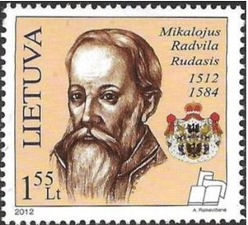
27 Dec 1587 - 30 Apr 1632 Žygimantas III (Zygmunt III) (b. 1566 - d. 1632)
(= King of Sweden Sigismund)
30 Apr 1632 - 6 Feb 1633 Jonas Stanislovas Sapiega (b. 1589 - d. 1635)
(Jan Stanisław Sapieha)-Grand Marshal
6 Feb 1633 - 20 May 1648 Vladislovas IV (Władysław IV) (b. 1595 - d. 1648)
20 May 1648 - 17 Jan 1649 Aleksandras Liudvikas (b. 1594 - d. 1654)
Radvila -Grand Marshal
(Aleksander Ludwik Radziwiłł)
17 Jan 1649 - 16 Sep 1668 Jonas II Kazimieras (b. 1609 - d. 1672)
(Jan II Kazimierz)
16 Sep 1668 - 29 Sep 1669 Kristupas Zaviša -Grand Marshal (b. 1578 - d. 1670)
(Krzysztof Zawisza)
29 Sep 1669 - 10 Nov 1673 Mykolas (Michał) (b. 1640 - d. 1673)
10 Nov 1673 - 2 Feb 1676 Aleksandras Hiliaris (b. 1626 - d. 1679)
Palubinskis -Grand Marshal
(Aleksander Hilary Połubiński)
2 Feb 1676 - 17 Jun 1696 Jonas III (Jan III) (b. 1629 - d. 1696)
17 Jun 1696 - 15 Sep 1697 Aleksandras Povilas Sapiega (b. 1672 - d. 1734)
-Court Marshal
(Aleksander Paweł Sapieha)
Grand princes¹
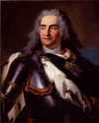 |  | 15 Sep 1697 - 16 Feb 1704 Augustas II "Stiprusis" (1st time)  (b. 1670 - d. 1733)  (election proclaimed 17 Jun 1697)  (continues in opposition to 24 Sep 1706)
16 Feb 1704 - 4 Oct 1705 Marcijonas Dominykas Vollovicius
(b. 16... - d. 1712) (Grand Marshal)
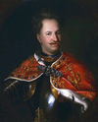 |  | 4 Oct 1705 - 8 Aug 1709 Stanislovas I Lescinskis  (1st time) (b. 1677 - d. 1766) (election proclaimed 12 Jul 1704)
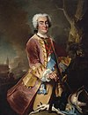 |  | 8 Aug 1709 - 1 Feb 1733 Augustas II "Stiprusis" (2nd time) (s.a.)
 |  | 1 Feb 1733 - 12 Sep 1733 Aleksandras Povilas Sapiega (b. 1672 - d. 1734) (Grand Marshal)
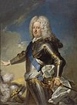 |  | 12 Sep 1733 - 30 Jun 1734 Stanislovas I Lescinskis  (2nd time) (s.a.) (abdicates 27 Jan 1736)
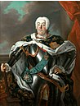 |  | 30 Jun 1734 - 5 Oct 1763 Augustas III  (b. 1696 - d. 1763)  (election proclaimed 5 Oct 1733)  (in opposition from 17 Jan 1734)
5 Oct 1763 - 25 Nov 1764 Ignotas Oginskis (Grand Marshal)
(b. 1698 - d. 1775)
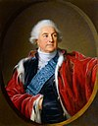 |  | 25 Nov 1764 - 7 Jan 1795 Stanislovas II Augustas Poniatovskis (b. 1732 - d. 1798) (election proclaimed 8 Sep 1764)
Russian Governors-general in Vilna (Vilnius)
30 Oct 1794 - 26 Nov 1798 Knyaz' Nikolay Vasilyevich Repnin (b. 1734 - d. 1801)
26 Nov 1798 - 26 Oct 1799 Boris Petrovich Lassie (b. 1737 - d. 1820)
(= Moritz de Lacy)
13 Nov 1799 - 19 Dec 1799 Ivan Petrovich Gorich-Menshoy (b. 1745 - d. 1811)
(acting)
19 Dec 1799 - 11 Jul 1801 Mikhail Illarionovich Golenyshtchev
-Kutuzov (1st time) (b. 1745 - d. 1813)
11 Jul 1801 - 20 Sep 1806 Levin August Theophil Graf von (b. 1745 - d. 1826)
Bennigsen
(= Graf Leontiy Leontyevich fon Bennigsen)
5 Oct 1806 - 3 Jul 1809 Aleksandr Mikhaylovich Rimskiy- (b. 1753 - d. 1840)
Korsakov (1st time)
3 Jul 1809 - 17 Apr 1812 Mikhail Illarionovich Golenyshtchev
-Kutuzov (2nd time) (s.a.)
27 Mar 1811 - 17 Apr 1812 Ivan Stepanovich Guriyev
(acting for Golenyshtchev-Kutuzov)
17 Apr 1812 - 28 Jun 1812 Aleksandr Mikhaylovich Rimskiy- (s.a.)
Korsakov (2nd time)
French Governor-General of Lithuania (Lituanie)
8 Jul 1812 - 10 Dec 1812 Dirk, graaf van Hogendorp (b. 1761 - d. 1822) Mil
(Dirk, comte Hogendorp)
French Imperial Commissioner to Lithuania (Lituanie)(for civil affairs)
13 Jul 1812 - 8 Dec 1812 Louis Pierre Édouard, baron Bignon (b. 1771 - d. 1841) Non-party
Russian Governors-general in Vilna (Vilnius)
8 Dec 1812 - 24 Dec 1830 Aleksandr Mikhaylovich Rimskiy- (s.a.)
Korsakov (3rd time)
24 Dec 1830 - 23 Aug 1831 Matvey Yevgrafovich Khrapovitskiy (b. 1784 - d. 1847)
23 Aug 1831 - 18 Mar 1840 Knyaz' Nikolay Andreyevich (b. 1792 - d. 1847)
Dolgorukiy (Dolgorukov)
President of the Supreme Central Committee of Lithuania (in rebellion)
26 Mar 1831 - 11 Jun 1831 Stanisław Szumski (b. 1790 - d. 1871) Lib
(Stanislovas Šumskis)
President of the Polish Provisional Central Government in Lithuania (in rebellion)
11 Jun 1831 - 9 Jul 1831 Tadeusz hrabia Tyszkiewicz (b. 1774 - d. 1852) Lib
(= Tadas grafas Tiškevičius)
Governors-general of the Government-general of Lithuania and also Northwestern Region
(Vilna, Kovno, Grodno, Minsk, Mogilyov and Vitebsk)
1 Apr 1840 - 10 Feb 1850 Fyodor Yakovlevich Mirkovich (b. 1789 - d. 1866)
15 Mar 1850 - 10 Dec 1855 Ilya Gavrilovich Bibikov (b. 1794 - d. 1867)
10 Dec 1855 - 1 May 1863 Vladimir Ivanovich Nazimov (b. 1802 - d. 1874)
1 May 1863 - 17 Apr 1865 Mikhail Nikolayevich Muravyov (b. 1796 - d. 1866)
(from 1865, Graf Mikhail Nikolayevich Muravyov)
14 Jul 1864 - 17 Apr 1865 Aleksandr L'vovich Potapov (b. 1818 - d. 1886)
(acting for Muravyov)
17 Apr 1865 - 9 Oct 1866 Konstantin Petrovich von Kauffmann (b. 1818 - d. 1882)
9 Oct 1866 - 2 Mar 1868 Eduard Trofimovich Baranov (b. 1811 - d. 1884)
5 Sep 1867 - 2 Mar 1868 Mikhail Ivanovich Chertkov (b. 1829 - d. 1905)
(acting for Baranov)
2 Mar 1868 - 22 Jul 1874 Aleksandr L'vovich Potapov (s.a.)
28 Mar 1868 - 22 Sep 1870 Knyaz' Pyotr Romanovich Bagration (b. 1818 - d. 1876)
(acting for Potapov)
22 Jul 1874 - 18 May 1880 Pyotr Pavlovich Albedinskiy (b. 1826 - d. 1883)
18 May 1880 - 19 Jun 1884 Graf Eduard Ivanovich Totleben (b. 1818 - d. 1884)
(Todleben)
5 Nov 1882 - 14 Jan 1884 Aleksandr Pavlovich Nikitin (b. 1824 - d. 1891)
(acting for Totleben)
14 Jan 1884 - 1 Jan 1893 Ivan Semyonovich Kakhanov (b. 1825 - d. 1909)
(Kokhanov)(acting to 6 Sep 1884)
1 Jan 1893 - 31 May 1897 Pyotr Vasilyevich Orzhevskiy (b. 1839 - d. 1897)
31 May 1897 - 6 Dec 1897 Vacant
6 Dec 1897 - 9 Mar 1901 Vitaliy Nikolayevich Trotskiy (b. 1835 - d. 1901)
9 May 1901 - 15 Sep 1902 Vacant
15 Sep 1902 - 26 Sep 1904 Knyaz' Pyotr Dmitriyevich (b. 1857 - d. 1914)
Svyatopolk-Mirskiy
12 Oct 1904 - 19 Dec 1905 Aleksandr Aleksandrovich Freze (b. 1840 - d. 1918?)
19 Dec 1905 - 1909 Konstantin Faddeyevich Krshivitskiy(b. 1840 - d. 1910)
(Krzhivitskiy)
1909 - 30 Jun 1912 Vacant
30 Jun 1912 - 23 Nov 1915 Post abolished
Governors of Vilna
2 Jun 1906 - 7 May 1912 Dmitriy Nikolayevich Lyubimov (b. 1864 - d. 1942)
7 May 1912 - 18 Sep 1915 Pyotr Vladimirovich Veryovkin (b. 1862 - d. 1946)
(in Russia exile to 1916)
1916 - 1917 Graf Aleksandr Nikolayevich (b. 1878 - d. 1919)
Tolstoy (in Russia exile)
Governors of Kovno
24 Apr 1904 - 31 Dec 1912 Pyotr Vladimirovich Veryovkin (s.a.)
31 Dec 1912 - 18 Aug 1915 Nikolay Dmitriyevich Gryazev (b. 1868 - d. af.1917)
(in Russia exile to 1917)
Heads of the German Military Administration for Vilnius
23 Nov 1915 - May 1916 Karl Benedix Wilhelm von Alten (b. 1852 - d. 1937) Mil
May 1916 - 3 Mar 1917 Carl Franz Adolph von Harbou (b. 1860 - d. 1927) Mil
Heads of the German Military Administration for Lithuania
4 Mar 1917 - 28 Feb 1918 Franz Joseph Fürst zu Isenburg- (b. 1869 - d. 1939) Mil
Birstein
1 Mar 1918 - 1 Aug 1918 Theodor Alexander von Heppe (b. 1870 - d. 1854) Mil
Head of the German Military Administration of Lithuania (Litauen)
1 Aug 1918 - Nov 1918 Carl Franz Adolph von Harbou (s.a.) Mil
Reichskommissare für Litauen (und die Baltischen Provinzen)
15 Mar 1918 - 5 Jun 1918 Robert Franz Karl Graf von (b. 1866 - d. 1959) Non-party
Keyserlingk-Cammerau
5 Jun 1918 - 8 Nov 1918 Friedrich Karl Alexander Cäsar (b. 1869 - d. 1946) Non-party
Freiherr von Falkenhausen
Chairman of the Lithuanian Council
24 Sep 1917 - 11 Jul 1918 Antanas Smetona (b. 1874 - d. 1944) TPP
King³
13 Jul 1918 - 2 Nov 1918 Mindaugas II (b. 1864 - d. 1928)
(= Herzog Wilhelm von Urach, Graf von Württemberg)
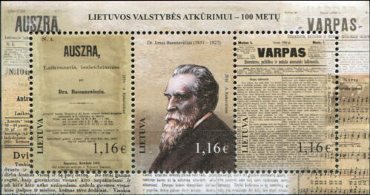
President of the Lithuanian State Council
11 Jul 1918 - 6 Apr 1919 Antanas Smetona (s.a.) TPP
4 Apr 1919 - 6 Apr 1919 Justinas Staugaitis (b. 1866 - d. 1943) LKDP
+ Stasys Šilingas (b. 1885 - d. 1962) LUS
(acting for Smetona)
State President
6 Apr 1919 - 19 Jun 1920 Antanas Smetona (s.a.) TPP
Presidents
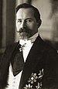 | 2 Nov 1918 - 19 Jun 1920 Antanas Smetona (1st time)  (b. 1874 - d. 1944)  (chairman Lithuanian National Council Presidium to 4 Apr 1919)
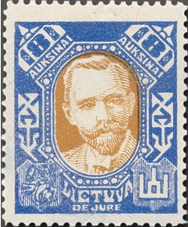 |  |  | 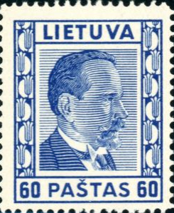
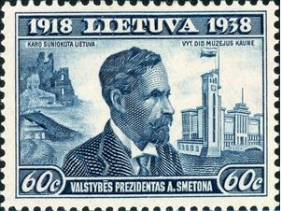
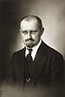 | 19 Jun 1920 - 7 Jun 1926 Aleksandras Stulginskis (1st time)  (b. 1885 - d. 1969 (acting to 21 Dec 1922)
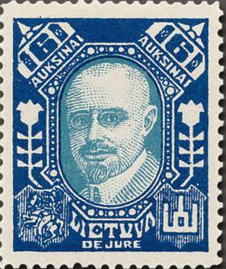 |  |  | 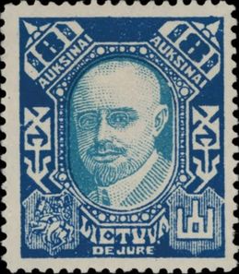
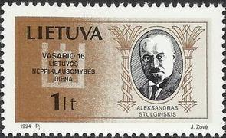
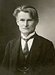 | 7 Jun 1926 - 18 Dec 1926 Kazys Grinius  (b. 1866 - d. 1950)
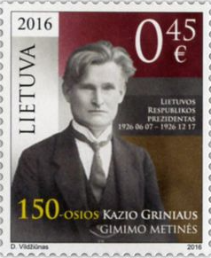 |  |  | 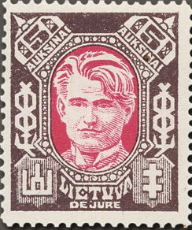
18 Dec 1926 - 19 Dec 1926 Jonas Staugaitis (acting)
(b. 1868 - d. 1952)
19 Dec 1926 (hours) Aleksandras Stulginskis (2nd time) (s.a.)
(acting)
 | 19 Dec 1926 - 15 Jun 1940 Antanas Smetona (2nd time) (s.a.)
15 Jun 1940 - 17 Jun 1940 Antanas Merkys (acting)
(b. 1887 - d. 1955)
17 Jun 1940 - 3 Aug 1940 Justas Paleckis
(b. 1899 - d. 1980)
Commander-in-chief of the German Army Group North (Heeresgruppe Nord)
24 Jun 1941 - 4 Jul 1941 Wilhelm Ritter von Leeb (b. 1876 - d. 1956) Mil
Commander of the German Rear Army Area North (Heeresgebiet Nord)
5 Jul 1941 - 1 Sep 1941 Franz von Roques (b. 1877 - d. 1967) Mil
Generalkommissar für Litauen
1 Sep 1941 - 13 Jul 1944 Theodor Adrian von Renteln (b. 1897 - d. 1946) NSDAP
(in Memel exile to 28 Jan 1945)
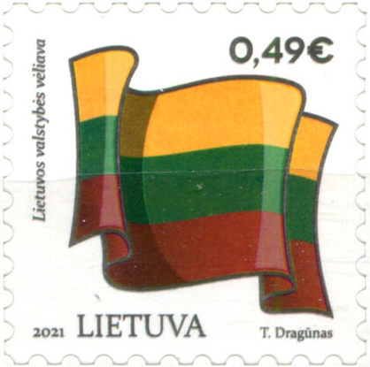
Chairman of the Supreme Council of the Republic of Lithuania
11 Mar 1990 - 25 Nov 1992 Vytautas Landsbergis (b. 1932) LPS
Presidents
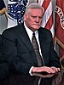 | 25 Nov 1992 - 25 Feb 1998 Algirdas Brazauskas  (b. 1932 - d. 2010) (acting to 25 Feb 1993)
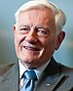 | 26 Feb 1998 - 25 Feb 2003 Valdas Adamkus (1st time)  (b. 1926)
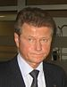 | 26 Feb 2003 - 6 Apr 2004 Rolandas Paksas  (b. 1956)
6 Apr 2004 - 12 Jul 2004 Arturas Paulauskas (acting)
(b. 1953)
 | 12 Jul 2004 - 12 Jul 2009 Valdas Adamkus (2nd time) (s.a.)
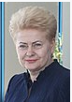 | 12 July 2009 – 12 July 2019 Dalia Grybauskaite (f)  (b. 1956)
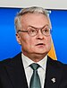 | 12 July 2004 – 12 July 2009 Valdas Adamkus  born 3 November 1926
Land Marshals (chief ministers)
(Lithuanian with Polish names in parentheses)
c.13 Jan 1407-20 Apr 1411 Stanislovas Čupurna (b. 13.. - d. 1411)
(Stanisław Czupurna)
c.31 May 1412-15 Oct 1432 Rumboldas Valimantavičius (b. 1371 - d. 1432)
(Rumbold Wolimuntowicz)
c.20 Jan 1433-27 Feb 1434 Radvila Astikaitis (1st time) (b. 1384 - d. 1477)
(Radziwiłł Ostykowicz)
c.28 May 1438- 9 Aug 1459 Petras Montigerdavicius (s.a.)
(Piotr Janowicz Montygerdowicz)
c.27 May 1463-22 Nov 1474 Radvila Astikaitis (2nd time) (s.a.)
c.1476 Stankus Sudijovaitis (b. c.1410 - d. 1481)
(Stanisław Sudywojowicz)
c.14 Jul 1477? - c.1479 Martynas Goštautas (b. 1430 - d. 1483)
(Marcin Gasztołd)
c.1 Nov 1480 - 30 Mar 1490 Bagdonas Andriejaitis Sakaitis (d. 1491)
(Bohdan Andrzejewicz Sakowicz)
1490 - 6 Dec 1497 Petras Jonaitis Mangirdaitis (s.a.)
(Piotr Janowicz Montygerdowicz)
1497 - May 1498 Grigorijus Astikas (1st time) (b. 145. - d. 1518)
(Grigorij Ostik)(acting)
May 1498 - 2 Feb 1508 Jonas Jurgaitis Zaberezinskis (s.a.)
(Jan Jurjewicz Zabrzeziński)
(or Zaberezhsky)
2 Feb 1508 - May 1512 Grigorijus Astikas (2nd time) (s.a.)
(acting)
May 1512 - Sep? 1513 Stanislovas Piotrowicz (b. 145. - d. 1513)
(or Pietraszkowicz) Kiška
(Stanisław Piotrowicz Kiszka)
Sep? 1513 - 9 Apr 1514 Grigorijus Astikas (3rd time) (s.a.)
(acting)
9 Apr 1514 - Mar? 1522 Mikalojus Radvila (b. c.1474 - d. 1522)
(Mikołaj Radziwiłł)
Mar? 1522 - May 1522 Jurgis Ivanovičius Iljiničius (b. 148. - d. 1526)
(Jerzy Iwanowicz Ilinicz)(acting)
May 1522 - Sep? 1537 Jonas Jonavičius Zabžezinskis (b. 146. - d. 1537)
(Jan Janowicz Zabrzeziński)
Sep? 1537 - Apr 1541 Jurgis Mikalojaus Radvila (acting) (b. c.1480 - d. 1541)
(Jerzy Mikołajewicz Radziwiłł)
Apr 1541 - Oct 1544 Ivanas Hornostajus (acting) (b. c.1480 - d. 1558)
(Iwan Hornostaj)
Oct 1544 - 28 May 1565 Mikalojus Radvila Juodasis (b. 1515 - d. 1565)
(Mikołaj Radziwiłł Czarny)
29 May 1565 - 11 Mar 1566 Ostapas (Eustachijus) Valavičius (b. c.1520 - d. 1587)
(Ostafi Bohdanowicz Wołłowicz)
(acting)
11 Mar 1566 - 1 Jul 1569 Jonas Jeronimas Chodkevičius (s.a.)
(Jan Hieronimowicz Chodkiewicz)
Grand Marshals (chief ministers)
(Lithuanian with Polish names in parentheses)
1 Jul 1569 - 4 Aug 1579 Jonas Jeronimas Chodkevičius (s.a.)
4 Aug 1579 - 1 Jun 1586 Mikalojus Kristupas Radvila (b. 1549 - d. 1616)
Našlaitėlis (acting to 25 Oct 1579)
(Mikołaj Krzysztof Radziwiłł Sierotka)
1 Jun 1586 - 13 Jul 1592 Albertas Radvila (s.a.)
(Albrecht Radziwiłł)
13 Jul 1592 - 22 Oct 1592 Mikalojus Talvosas (1st time) (b. 155. - d. 1598)
(Mikołaj Talwosz) (acting)
22 Oct 1592 - 9 Oct 1595 Stanislovas Radvila (b. 1559 - d. 1599)
(Stanisław Radziwiłł)
9 Oct 1595 - May 1596 Mikalojus Talvosas (2nd time) (s.a.)
(acting)
May 1596 - 12 May 1615 Kristupas Manvydas Dorohostaiskis (b. 1562 - d. 1615)
(Krzysztof Mikołajewicz Dorohostajski)
(acting to 8 May 1597)
12 May 1615 - 10 Sep 1619 Petras Viesiolovskis (b. 157. - d. 1621)
(Piotr Wiesiołowski)
(acting to 27 Jun 1615)
10 Sep 1619 - 10 Apr 1635 Jonas Stanislovas Sapiega (s.a.)
(Jan Stanisław Sapieha)
(acting to 14 Nov 1621)
10 Apr 1635 - 19 Apr 1637 Kristupas Viesiolovskis (b. 159. - d. 1637)
(Krzysztof Wiesiołowski)
(acting to 20 Apr 1635)
19 Apr 1637 - 3 Mar 1654 Aleksandras Liudvikas Radvila (s.a.)
(Aleksander Ludwik Radziwiłł)
(acting to 2 May 1637)
3 Mar 1654 - 11 Nov 1669 Kristupas Zaviša (s.a.)
(Krzysztof Zawisza)
(acting to 11 Apr 1654)
11 Nov 1669 - 3 Nov 1679 Aleksandras Hilaris Palubinskis (s.a.)
(Aleksander Hilary Połubiński)
3 Nov 1679 - 1679 Teodoras Lackis (acting) (b. c.1617 - d. 1683)
(Teodor Aleksander Lacki)
1679 - 8 Dec 1690 Stanislovas Kazimieras Radvila (b. 1648 - d. 1690)
(Stanisław Kazimierz Radziwiłł)
8 Dec 1690 - 29 Apr 1695 Jonas Dolskis (Jan Dolski) (b. 1637 - d. 1695)
(acting to 7 May 1691)
29 Apr 1695 - 27 Nov 1703 Aleksandras Povilas Sapiega (s.a.)
(Aleksander Paweł Sapieha)
(acting to 14 Jul 1698; recognized by
the Grand Prince Stanislovas I
to 9 May 1708) (1st time)
27 Nov 1703 - 4 Feb 1704 Mykolas Servacijus Višnioveckis (b. 1680 - d. 1744)
(Michał Serwacy Wiśniowiecki)
(grand hetman)
4 Feb 1704 - 5 Aug 1712 Marcijonas Dominykas Vollovicius (s.a.)
(Marcjan Dominik Wołłowicz)
5 Aug 1712 - 10 Apr 1713 Juozas Vandalinas Mnisekas (acting)(b. 1670 - d. 1747)
(Józef Wandalin Mniszech)
10 Apr 1713 - 4 Jan 1734 Aleksandras Povilas Sapiega (s.a.)
(2nd time)
4 Jan 1734 - 15 Apr 1750 Povilas Karolis Sanguška (b. 1680 - d. 1750)
(Paweł Karol Sanguszko)
(acting to 4 Feb 1734)
15 Apr 1750 - 22 Feb 1768 Ignotas Oginskis (Ignacy Ogiński) (s.a.)
(acting to 21 Aug 1750)
22 Feb 1768 - 12 May 1781 Juozapas Paulinas Sanguška (b. 1740 - d. 1781)
(Józef Paulin Sanguszko)
(acting to 7 Mar 1768)
29 Feb 1768 - 23 Jun 1768 Grafas Mykolas Jonas Pacas (b. 1730 - d. 1787)
(Hrabia Michał Jan Pac)
(Marshal General of the Crown [of Baro Confederation],
in rebellion)
12 May 1781 - 23 May 1790 Vladislovas Rokas Gurovskis (b. 1717 - d. 1790)
(Władysław Roch Gurowski)
(acting to 23 May 1781)
23 May 1790 - 3 May 1791 Grafas Romanas Ignotas Potockis (b. 1750 - d. 1809)
(Roman Ignacy Franciszek Potocki)
(acting to 16 Apr 1791)
19 May 1791 - 7 May 1793 Stanislovas Soltanas (acting) (s.a.)
(Stanisław Sołtan)
7 May 1793 - 24 Apr 1794 Grafas Liudvikas Tiškevičius (b. c.1748 - d. 1808)
(Ludwik Tyszkiewicz)
Chairmen of the Supreme Lithuanian Council
24 Apr 1794 - 12 Jun 1794 Jokūbas Jasinskis (b. 1761 - d. 1794) Mil
(Jakub Jasiński)
12 Jun 1794 - 11 Oct 1794 Central Deputation [chair rotating]
- Juozapas Niesiolovskis (b. 1728 - d. 1814)
(Józef Niesiołowski)
- Antanas Tyzenhauzas (b. 1756 - d. 1816)
(Antoni Tyzenhauz, Anton von Tiesenhausen)
- Jurgis Bialopetrovičius (b. 1740 - d. 1812)
(or Belapetryavichyus)
(Jerzy Białopiotrowicz)
- Stanislovas Mirskis (b. 1756 - d. 1805/15)
(Stanisław Mirski)
- Grafas Benediktas Morikonis (b. 1750? - d. 1812)
(Benedykt Morykoni)
- Davidas Pilchauskas (Pilshauskas)(b. 1735 - d. 1803)
(Dawid Pilchowski)
Presidents of the Commission of the Provisional Government of Lithuania
2 Jul 1812 - 18 Jul 1812 Józef hrabia Sierakowski herbu (b. 1765 - d. 1831) Non-party
Dołęga (acting)
(= Joseph, comte Sierakowski)
(presiding officer)
18 Jul 1812 - 28 Aug 1812 Stanisław hrabia Pereświet-Sołtan (b. 1758 - d. 1836) Non-party
herbu Syrokomla
(= Stanislovas Soltanas = Stanislas, comte Soltan)
28 Aug 1812 - 8 Dec 1812 Dirk, graaf van Hogendorp (s.a.) Mil
(Dirk, comte Hogendorp)
6 Dec 1812 - 11 Dec 1812 Stanisław hrabia Pereświet-Sołtan (s.a.) Non-party
herbu Syrokomla
(de facto acting for Hogendorp)
(continues in Kaunas 11 Dec 1812, in Duchy of Warsaw exile
21 Dec 1812 - 1 May 1813; in Dresden, Saxony 15 Jul-30 Jul 1813)
President of the Administrative Commission
Jul 1812 - Dec 1812 Scipion Cyprien Jules Louis-Martin (b. 1780 - d. 1843) Mil
Marie-Elisabeth, marquis de Nicolaï
Chairman of the Provisional Provincial Government in Lithuania and Belarus (in rebellion)
2 Feb 1863 - 11 Mar 1863 Wincenty Konstanty Kalinowski (b. 1838 - d. 1864) Rad
(Vincentas Konstantinas Kalinauskas)
Chairman of the Managing Department for the Provinces of Lithuania (from 26 Jun 1863, Chairman of the Executive Department for Lithuania) (in rebellion)
11 Mar 1863 - 12 Aug 1863 Jakób (Jakub) Wilhelm Gieysztor z (b. 1827 - d. 1897) Lib
Giejsztorów
(Jokūbas Wilhelm Geištoras)
12 Aug 1863 - 10 Feb 1864 Wincenty Konstanty Kalinowski (s.a.) Rad
(acting)
Minister-presidents of the Provisional Government
23 Jun 1941 - 24 Jun 1941 Kazys Škirpa (in Berlin, Germany) (b. 1895 - d. 1979) LAF
23 Jun 1941 - 5 Aug 1941 Juozas Ambrazevičius (b. 1903 - d. 1974) LAF
(acting; from 24 Jun 1941 in rebellion)
First General Councillor of the Lithuanian Self-Administration
(Erster Generalratsmann der Litauischen Selbstverwaltung)
1 Sep 1941 - 13 Jul 1944 Petras Kubiliūnas (b. 1894 - d. 1946) Non-party
Chairman of the Council of Ministers (prime minister)
11 Mar 1990 - 17 Mar 1990 Kazimira Danutė Prunskienė (f) (b. 1943) LKP
(= Kazimyra Danute Prunskene)
Minister-presidents (prime ministers)
17 Mar 1990 - 10 Jan 1991 Kazimira Danutė Prunskienė (f) (s.a.) LKP
10 Jan 1991 - 13 Jan 1991 Albertas Šimėnas (b. 1950) LKDP
13 Jan 1991 - 23 Jul 1992 Gediminas Vagnorius (1st time) (b. 1957) Non-party
17 Jul 1992 - 23 Jul 1992 Algis Dobravolskas (b. 1951) Non-party
(acting for Vagnorius)
23 Jul 1992 - 17 Dec 1992 Aleksandras Algirdas Abišala (b. 1955) Non-party
17 Dec 1992 - 31 Mar 1993 Bronislovas Lubys (b. 1938 - d. 2011) Non-party
31 Mar 1993 - 8 Feb 1996 Adolfas Šleževičius (b. 1948 - d. 2022) LDDP
8 Feb 1996 - 10 Dec 1996 Laurynas Mindaugas Stankevičius (b. 1935 - d. 2017) LDDP
(acting to 19 Mar 1996)
10 Dec 1996 - 4 May 1999 Gediminas Vagnorius (2nd time) (s.a.) TS-LK
4 May 1999 - 10 Jun 1999 Irena Degutienė (f)(1st time) (b. 1949) TS-LK
(acting)
10 Jun 1999 - 27 Oct 1999 Rolandas Paksas (1st time) (s.a.) TS-LK
27 Oct 1999 - 11 Nov 1999 Irena Degutienė (f)(2nd time) (s.a.) TS-LK
(acting)
11 Nov 1999 - 9 Nov 2000 Andrius Kubilius (1st time) (b. 1956) TS-LK
9 Nov 2000 - 20 Jun 2001 Rolandas Paksas (2nd time) (s.a.) LLS
20 Jun 2001 - 12 Jul 2001 Eugenijus Gentvilas (acting) (b. 1960) LLS
12 Jul 2001 - 1 Jun 2006 Algirdas Mykolas Brazauskas (s.a.) LSDP
1 Jun 2006 - 18 Jul 2006 Zigmantas Balčytis (acting) (b. 1953) LSDP
18 Jul 2006 - 9 Dec 2008 Gediminas Kirkilas (b. 1951) LSDP
9 Dec 2008 - 13 Dec 2012 Andrius Kubilius (2nd time) (s.a.) TS-LKD
13 Dec 2012 - 13 Dec 2016 Algirdas Butkevičius (b. 1958) LSDP
13 Dec 2016 - 11 Dec 2020 Saulius Skvernelis (b. 1970) LVZS
11 Dec 2020 - Ingrida Šimonytė (f) (b. 1974) Non-party
11 Dec 2020 - Ingrida Šimonytė (f) (b. 1974) Non-party
Republic of Lithuania in Exile
Heads of the Diplomatic Service
15 Jun 1940 - 24 Dec 1983 Stasys Lozoraitis (in Rome) (b. 1898 - d. 1983)
2 Dec 1941 - 15 Jun 1945 Jurgis Šaulys (in Switzerland) (b. 1879 - d. 1948)
(acting for Lozoraitis)
24 Dec 1983 - 15 Nov 1987 Stasys Antanas Bačkis (b. 1906 - d. 1999)
(in Washington, D.C.)
15 Nov 1987 - 6 Sep 1991 Stasys Lozoraitis (b. 1924 - d. 1994)
(in Washington, D.C.)
Resistance to German and Soviet Occupation 1943-1956
Note: Anti-German (at the same time also anti-Soviet) resistance already began in 1941 by establishment of Lithuanian Freedom Army. All resistance groups united in Oct 1943 to form Supreme Lithuanian Liberation Committee. After the World War II anti-Soviet resistance groups united in Feb 1949, sometimes having full control over large areas of western Lithuania. Resistance continued into Oct 1956 when their activities were suppressed by Soviet troops.
Chief of the Supreme Lithuanian Liberation Committee
25 Oct 1943 - 30 Apr 1944 Steponas Kairys (b. 1878 - d. 1964) LSDP
Chairmen of the Lithuanian Freedom Fighters' Council and
Commanders of the Lithuanian Defence Forces
10 Feb 1949 - Jan 1950 Jonas Žemaitis (1st time) (b. 1909 - d. 1954) Mil
Jan 1950 - Feb 1953 Adolfas Ramanauskas (1st time) (b. 1918 - d. 1957) Mil
Feb 1953 - 30 May 1953 Jonas Žemaitis (2nd time) (s.a.) Mil
30 May 1953 - 12 Oct 1956 Adolfas Ramanauskas (2nd time) (s.a.) Mil
German Military Administration 1918-1919
Commanders of the German Troops in Lithuania
4 Mar 1918 - 25 Feb 1919 Erich Georg Sebastian von (b. 1861 - d. 1922) Mil
Falkenhayn
German Chief Representative in Lithuania
(Generalbevollmächtigter in Litauen)
5 Nov 1918 - Dec 1919 Ludwig Zimmerle (b. 1867 - d. 1925) Non-party
(also from 1919, chief of Civil Administration in Lithuania)
Noble titles: Count = Grafas/Hrabia (in German and Russian: Graf); Prince/Princess = Książę/Księżna (in Russian: Knyaz') the style Kniaz/Kniahini or Kniagini (title was also used is easten parts of Poland for old families of tribal rulers, equal to prince/książę, but more distinguished).
¹The style "didysis kunigaikštis" is better rendered "grand prince" rather than "grand duke", just as is the case with the Russian "velikiy knyaz'". The style of the polity should therefore be correctly rendered as "Grand Principality".
²Under the elective monarchy, a grand prince assumed office upon his coronation at the Coronation Diet. The record also includes the date of proclamation of the election at the Election Diet. From 6 Jan 1573, during a vacancy, the primate of Poland ex officio (occasionally another prelate, in emergency situations) headed the state with the style Interrex. Informally from 4 Jul 1569, constitutionally from 3 May 1791, Poland and Lithuania constituted the United Commonwealth of Two Nations; the Polish king also had the style of Grand Prince of Lithuania, and the two countries were governed together and were represented on the Diets. Although de jure the Polish Interrex only dealt with Poland during a vacancy in the monarchy (the Lithuanian Council of State [Lietuvos Ponu Taryba], chaired by the Grand Marshal [Lietuvos didysis marsalka] dealing with Lithuania), this is de facto a spurious distinction.
The full style of Grand Princes of Lithuania (and Polish kings) from 1573 was (in official Latin): Dei Gratiae Rex Poloniae, Magnus Dux Lituaniae, Russiae, Prussiae, Masoviae, Samogithiae, Kiioviae, Volhyniae, Podoliae, Podlachiae, Livoniae, Smolensciae, Severiae, Czernichoviaeque; (in Polish) Z Bożej łaski, Król Polski, Wielki Książę Litewski, Ruski, Pruski, Mazowiecki, Żmudzki, Kijowski, Wołyński, Podolski, Podlaski, Inflancki, Smoleński, Siewierski i Czernihowski ("By the Grace of God, King of Poland, Grand Duke of Lithuania, Russia, Prussia, Mazovia, Samogithia, Kiev, Volhynia, Podolia, Podlachia, Livonia, Smolensk, Severia and Chernigov").
³On 11 Jul 1918, the State Council declared Lithuania to be a monarchy and invited Herzog Wilhelm von Urach, Graf von Württemberg (s.a.) to be king, under the unofficially proposed style of Mindaugas II, he accepted the offer, but he did not come to Lithuania and was not installed and was not recognized by the German occupation authorities. On 2 Nov 1918, the State Council suspended the invitation and Lithuania was organized as a republic.
Territorial Disputes: Lithuania and Russia committed to demarcating their boundary in 2006 in accordance with the land and maritime treaty ratified by Russia in May 2003 and by Lithuania in 1999; Lithuania operates a simplified transit regime for Russian nationals traveling from the Kaliningrad coastal exclave into Russia, while still conforming, as a EU member state having an external border with a non-EU member, to strict Schengen border rules; boundary demarcated with Latvia and Lithuania; as of Jan 2007, ground demarcation of the boundary with Belarus was complete and mapped with final ratification documents in preparation.
Party abbreviations: LKDP = Lietuvos Krikščionių Demokratų Partija (Christian Democratic Party of Lithuania, christian-democratic, Mar 1917-1936, re-est.28 Jan 1990); LSDP = Lietuvos Socialdemokratų Partija (Social-Democratic Party of Lithuania, social-democratic, 1 Jun 1896-6 Feb 1936, re-est.27 Apr 1989); LTS = Lietuvių Tautininkų Sąjunga (Lithuanian Nationalist Union, called "Tautininkai", nationalist, 1936-39 state party, 9 Aug 1924-1940, re-est.23 Feb 1990); LVZS = Lietuvos Valstiečių ir Žaliųjų Sąjunga (Lithuanian Peasant and Greens Union, agrarian, centrist, Green conservative, formerly LVLS, est.Jan 2012); TPP = Tautos Pažangos Partija (Party of National Progress, 1916-19 Aug 1924, renamed LTS, re-est.28 May 1994); TS-LKD = Tėvynės Sąjunga-Lietuvos Krikščionys Demokrataiai (Homeland Union–Christian Democrats of Lithuania, center-right, formerly TS-LK, est.17 May 2008); Mil = Military;
- Former parties: LAF = Lietuvos Aktyvistų Frontas (Activist Front of Lithuania, anti-Soviet resistance organization, 17 Nov 1940-26 Sep 1941); LDDP = Lietuvos Demokratine Darbo Partija (Democratic Labor Party of Lithuania, socialist, former LKP, 8 Dec 1990-27 Jan 2001, renamed LSDP); LDTS = Lietuvos Darbo Liaudies Sąjunga (Working People's Union of Lithuania, communist LKP front bloc, 1940); Lib = Biali/Stronnictwo Białych (Whites/White Party, liberals, opposed Rad, c.1858); LKP = Lietuvos Komunistų Partijos/Kommunisticheskaya Partiya Litvy (Communist Party of Lithuania, communist, named 1940-13 Oct 1952 Lietuvos Komunistų [Bolševikų] Partijos [Communist Party (Bolsheviks) of Lithuania], 1940-20 Dec 1989 part of CPSU, 3 Oct 1918-Nov 1920 part of LBKP, 1940-7 Dec 1989 state party, Nov 1920-8 Dec 1990, renamed LDDP); LLDP = Lietuvos Liberalų Demokratų Partija (Liberal Democratic Party of Lithuania, center-right, populist, 9 Mar 2002-13 May 2006, renamed Tvarka ir teisingumas [Order and Justice]); LLS = Lietuvos Liberalų Sąjung (Liberal Union of Lithuania, liberal, 21 Jun 1990-31 May 2003, merged into Liberalų ir centro sąjunga); LPS = Lietuvos Persitvarkymo Sąjūdis (Reform Movement of Lithuania, "Sąjūdis," pro-independence, from 1990 shortened to Lietuvos Sąjūdis, 3 Jun 1988-1 May 1993, merged into TS-LK); LSLDP = Lietuvos Socialistų Liaudininkų Demokratų Partija (Socialist People's Democratic Party of Lithuania, 19 Nov 1917-5 Dec 1922, merged into LVLS); LUS = Lietuvos Ukininku Sąjunga (Lithuanian Farmer's Union, agrarian, 1919-1936); LVS = Lietuvos Valstiečių Sąjunga (Peasant Union of Lithuania, leftist agrarian, 28 Dec 1905-5 Dec 1922, merged into LVLS); LVLS = Lietuvos Valstiečių Liaudininkų Sąjunga (Peasant Populist Union of Lithuania, "Liaudininkai," center-left, merger of LSLDP and LVS, 5 Dec 1922-1936 and Feb 2006-Jan 2012, renamed Jan 2012 as LVZS); NS = Naujoji Sąjunga (Socialliberalai)(New Union [Social Liberals], center-left, 25 Apr 1998-9 Jul 2011, merged into Darbo partija [Democratic Party]); NSDAP = Nationalsozialistische Deutsche Arbeiterpartei (National Socialist German Workers' Party, Nazi fascist, authoritarian, German nationalist, only legal party 1941-1944); Rad = Czerwoni/Stronnictwo Czerwonych (Reds/Red Party, radical liberals, opposed Lib, c.1861); TS-LK = Tėvynės Sąjunga-Lietuvos Konservatoriai (Homeland Union - Conservatives of Lithuania, liberal conservative reformist, 1 May 1993-17 May 2008, merged into TS-LKD)
Alternative governments: Lithuanian S.S.R. and "Litbel"
Note: Names are given in Lithuanian with Belarusian in parenthesis.
5 Jan 1919 - 19 Apr 1919 Soviet Russian occupation of Vilnius.
5 Jan 1919 Lithuanian Socialist Conciliar ("Soviet") Republic
(Litovskaya Socialisticheskaya Sovetskaya Respublika) declared,
in opposition to the Republic of Lithuania (proclamation in
Russia exile dated 16 Dec 1918).
27 Feb 1919 Merged with the Byelorussian Socialist Soviet Republic to
form the Socialist Conciliar ("Soviet") Republic of
Lithuania and Byelorussia ("Litbel")(Lietuvos ir Baltarusijos
Socialistinė Tarybų Respublika/Satsyyalistychnaya Savetskaya
Respublika Litvy i Bielarusi) under Russian pressure.
19 Apr 1919 Polish occupation of Vilnius (government moves to Minsk).
4 Jun 1919 Military and political union with the Russian S.F.S.R.
8 Aug 1919 Soviet troops lose Minsk, the government of "Litbel" moves to
Babruysk (Bobruysk).
1 Sep 1919 "Litbel" is dissolved in exile in Smolensk, Russia.
Chairman of the Provisional Revolutionary Workers' and Smallholders' (Peasants') Government
5 Jan 1919 - 27 Feb 1919 Vincas Mickevičius-Kapsukas (b. 1880 - d. 1935) LBKP
(Vintsas Mitskyevich-Kapsukas)
Chairman of the Central Executive Committee
27 Feb 1919 - 1 Sep 1919 Kazimieras Cichovskis (b. 1887 - d. 1937) LBKP
(Kazimir Hyenrykhavich Tsykhowski
= Kazimierz Cichowski)
Chairman of the Council of People's Commissars
27 Feb 1919 - 1 Sep 1919 Vincas Mickevičius-Kapsukas (s.a.) LBKP
Party abbreviation: LBKP = Lietuvos ir Baltarusijos Komunistų Partija/Kamunistychnaya Partyya Litvy i Byelarusi (Communist Party of Lithuania and Byelorussia, communist, state party, 3 Oct 1918 - Nov 1920, renamed LPK)
Alternative government: Central Lithuania
31 Dec 1918 - 5 Jan 1919 Polish occupation of Vilnius.
5 Jan 1919 - 19 Apr 1919 Soviet Russian occupation of Vilnius.
5 Jan 1919 - 19 Apr 1919 Part of Lithuanian Conciliar ("Soviet") Republic (from 27 Feb 1919
Socialist Conciliar ("Soviet") Republic of Lithuania and
Belorussia ["Litbel"]).
19 Apr 1919 - 17 Jul 1920 Polish occupation of Vilnius. .
12 Jul 1920 Recognized by Soviet Russia as part of Lithuania by Moscow
Treaty (ratified 14 Oct 1920).
17 Jul 1920 - 25 Aug 1920 Soviet Russian occupation of Vilnius.
7 Oct 1920 Lithuanian and Poland agree to a cease-fire and provisional
demarcation by Suwałki Agreement (to be effected 10 Oct 1920).
26 Aug 1920 Transferred to Lithuania.
9 Oct 1920 Polish "irregular" occupation of Vilnius.
12 Oct 1920 Central Lithuania (Polish: Litwa Środkowa) government established
by decree of the commander-in-chief of Central Lithuanian Army.
20 Feb 1922 Ziemia Wileńska (formerly Central Lithuania) is proclaimed part of
Poland, resolution of the Assembly of Wilno (Sejm Wileński).
2 Mar 1922 Act of unification is signed by the representatives of the
government of Poland and the members of the Assembly of Wilno.
24 Mar 1922 Resolution of the Constituent Assembly of Poland on approval of the
act of unification of 2 Mar 1922 is passed.
13 Apr 1922 Incorporation into Poland by law of 6 Apr 1919 (not recognized by
Lithuania)(see Wileńskie under Poland Voivodships 1919-1939).
18 Sep 1939 Occupied by Soviet Union.
28 Oct 1939 Vilnius restored to Lithuania.
Commissioners General of the Commissariat for the Eastern Lands
19 Feb 1919 - 5 May 1919 Ludwik Kolankowski (b. 1882 - d. 1956) Non-party
5 May 1919 - 9 Sep 1920 Jerzy Marcin Osmołowski (b. 1872 - d. 1952) Non-party
Polish Military Commander (of the 1st Lithuanian-Belarusian Infantry Division)
9 Oct 1920 - 12 Oct 1920 Lucjan Żeligowski (b. 1865 - d. 1947) Mil
Commander-in-Chief of the Central Lithuanian Army
12 Oct 1920 - 1 Dec 1921 Lucjan Żeligowski (s.a.) Mil
Presidents of Provisional Government Commission
12? Oct 1920 - 16 Jan 1921 Witold Abramowicz (b. 1874 - d.1940/41)Non-party
(acting to 29 Nov 1920)
16 Jan 1921 - 21 Nov 1921 Stefan Mokrzecki (acting) (b. 1862 - d. 1932) Mil
21 Nov 1921 - 13 Apr 1922 Aleksander Michał Marian (b. 1864 - d. 1943) Non-party
Meysztowicz
Samogitia (Zemaitija)
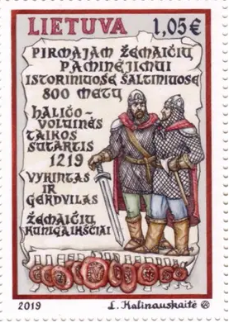
.... Principality of Samogitia (Zemaitija) established.
124. Vassal of Lithuania.
1337 – 1398 Part of fiefdom of Prince of Trakai.
31 Oct 1382 Ceded by Lithuania to the Teutonic Order (not ratified; again 1398
and 1404)(under effective Teutonic control only 1400-1401 and
1404-1409); Samogitians revolt in 1401 and 1409.
1 Feb 1411 Provisionally returned to Lithuania by Teutonic Order (confirmed
27 Sep 1422; actual Lithuanian rule from 1409).
1413 Eldership of Samogitia established.
1441 Autonomous within Lithuania, governed by an elected Elder (also
styled General Elder from the 16th century). The Grand Prince of
Lithuania takes style of the "Prince of Samogitia."
1655 – 1656 Occupied by Sweden (Samogitia briefly recognized Swedish protection
in 1655).
1701 - 1709 Occupied several times by Sweden.
3 May 1791 Autonomy formally abolished under the first constitution of the
Polish-Lithuanian Commonwealth (de facto continues until 1795).
25 Oct 1795 Annexed by Russia in the Third Partition of the Polish-Lithuanian
Commonwealth, the Russian Emperor adopts additional style of
"Prince of Samogitia" (de facto from 26 Apr 1795).
Princes
c.1219 Gerdvilas
- jointly with following -
bf.1219 - 1251 Vykintas (d. 1251)
bf.1253 - af.1260 Alminas
c.1261 - 1264 Treniota (b. c.1210 - d.1264)
126. - 132. Unrecorded period
bf.1326 - 1336 Margiris (d. 1336)
Princes of Trakai (in charge of Samogitia)
1337 - 15 Aug 1382 Kestutis (b. 1297 - d. 1382)
1382 - 1392 Skirgaila (Kazimieras) (b. c.1354 - d. 1396)
1392 – 1398 Vytautas (Witold) (Aleksandras) (b. 1344/50 - d. 1430)
Teutonic Vögte of Samogitia
1400 - Mar 1401 Heinrich von Schwelben
1404 - Aug 1409 Michael Küchmeister von Sternberg (b. c.1370 - d. 1423)
Stadholder (style in Polish Namiestnik)
1409 - 1412 Rumbaudas Valimantaitis (Lambertas)(b. c.1371 - d. 1432)
(Rumbold Walimuntowicz)
Elders (style in Lithuanian: Seniūnas, in Polish: Starosta)
(Lithuanian with Polish names in parentheses)
1412 - 1432 Mykolas Kęsgaila Valimantaitis (b. c.1380 - d. 1451/52)
(Michał Walimuntowicz Kieżgajło)
(1st time)
1432 - 1435 Jurgis Galminas (Jerzy Galimin) (b. c.1409 - d. c.1438)
1435 - 1440 Mykolas Kontautas (Michal Kontowt)
(1st time)
1440 - 1441 Mykolas Kęsgaila Valimantaitis (s.a.)
(2nd time)
1441 Daumantas (Dowmont)
1441 - 1443 Mykolas Kontautas (2nd time)
1443 - 1451 Mykolas Kęsgaila Valimantaitis (s.a.)
(3rd time)
1451 - 1485 Jonas Kęsgaila (b. c.1400 - d. 1485)
(Jan Michałowicz Kieżgajło)
1486 - 1526 Stanislovas Jonavičius Kęsgaila (b. c.1451 - d. 1527)
(Stanisław Janowicz Kieżgajł)
Apr 1527 - 1532 Stanislovas Stanislovaitis (b. 1503 - d. 1532)
Kęsgaila
(Stanisław Stanislawowicz Kieżgajło)
Sep 1532 - 1534 Petras Kiška (d. 1534)
(Piotr Stanislawowicz Kiszka z Ciechanowca)
1535 - Jan 1542 Jonas Radvila (b. c.1492 - d. 1542)
(Jan Mikolajewicz Radziwiłł)
May 1542 - Apr 1543 Motiejus Vaitiekaitis Kločka (d. 1543)
(Maciej Wojciechowicz Kłoczko)
1543 - 1544 Jurgis Bilevičius (b. c.1513 - d. 1544)
(Jerzy Marcinowicz Billewicz)
1544 - 1545 Stanislovas Mikalojaitis Kęsgaila (d. 1555)
(Stanisław Mikolajewicz Kieżgajł)
(did not take the office)
Aug 1545 - Dec 1561 Jeronimas Kotkevičius (b. c.1510 - d. 1561)
(or Chodkevičius)
(Hieronim Aleksandrowicz Chodkiewicz)
1562 – Dec 1563 Grigorijus Kotkevičius (b. c.1514 – d. 1572)
(Chodkevičius)
(Grzegorz Aleksandrowicz Chodkiewicz)
(administrator, style in Polish: Sprawca)
Dec 1563 - 4 Aug 1579 Jonas Kotkevičius (Chodkevičius) (b. c.1537 - d. 1579)
(Jan Hieronimowicz Chodkiewicz)
Aug 1579 - Oct 1579 Мikalojus Talvošas (castellan) (b. 15.. - d. 1598)
(Mikołaj Talwosz)
Oct 1579 - Dec 1588 Jonas Kiška (Jan Janusz Kiszka) (b. 1547 - d. 1592)
1589 - Feb 1590 Mykolas Naruševičius (1st time) (b. c.1560 - d. 1603)
(Mikołaj Naruszewicz)(castellan)
Feb 1590 - Oct 1595 Jurgis Kotkevičius (Chodkevičius) (b. 1570 - d. 1595)
(Jerzy Chodkiewicz)
1595 - Mar 1599 kunigaikštis Stanislovas Radvila (b. 1559 - d. 1599)
(książę Stanisław Radziwiłł)
Mar 1599 – Jul 1599 Mykolas Naruševičius (s.a.)
(2nd time) (castellan)
Jul 1599 - Jun 1616 grafas Jonas Karolis Katkevičius (b. 1560 - d. 1621)
(Chodkevičius)
(hrabia Jan Karol Chodkiewicz)
Jun 1616 - 1619 Adomas Tolvaišas (Adam Talwosz) (b. c.1550 - d. 1628)
(castellan)
1619 - 1636 Jeronimas Valavičius (b. c.1573 - d. 1636)
(Hieronim Wołłowicz)
1636 - Nov 1646 Jonas Alfonsas Liackis (b. c.1581 - d. 1646)
(Jan Alfons Lacki)
(castellan to Dec 1643)
Nov 1646 - Dec 1647 Aleksandras Naruševičius (b. 1582 - d. 1653)
(Aleksander Naruszewicz)
(castellan)
Dec 1647 - Apr 1653 kunigaikštis Jonušas Radvila (b. 1612 - d. 1655)
(książę Janusz Radziwiłł)
Apr 1653 – Aug 1653 Eustachijus Kirdzejus (b. c.1600 – d. 1661)
(Eustachy Kierdej) (castellan)
Aug 1653 - Jul 1668 Jurgis Karolis Hlebavičius (b. 1603 - d. 1669)
(or Glebavičius)
(Jerzy Karol Hlebowicz)
1655 – 1656 Magnus Gabriel greve de la Gardie (b. 1622 – d. 1686)
(Swedish governor-general of Samogitia)
Jul 1668 - Nov 1669 kunigaikštis Aleksandras Hilaris (b. 1626 - d. 1679)
Palubinskis
(książę Aleksander Hilary Połubiński)
Nov 1669 - Apr 1670 Stanislovas Vincentas Orda (b. 16.. - d. 1689)
(Stanisław Wincenty Orda)
(castellan) (1st time)
Apr 1670 - 1678 Viktorinas Konstantas Mlečka (b. c.1630 - d. 1678)
(Wiktoryn Konstanty Mleczko)
1678 - Dec 1681 Stanislovas Vincentas Orda (s.a.)
(castellan) (2nd time)
Dec 1681 - Apr 1682 Kazimieras Jonas Povilas Sapiega (b. 1642 - d. 1720)
(Kazimierz Jan Paweł Sapieha)
Apr 1682 - Oct 1684 Stanislovas Vincentas Orda (s.a.)
(castellan) (3rd time)
Oct 1684 - Feb 1696 Petras Mykolas Pacas (b. 1645 - d. 1696)
(Piotr Michał Pac)
Feb 1696 - Jun 1698 Vilhelmas Eustachijus Grotuzas (b. c.1640 - d. 1708)
(Wilhelm Eustachy Estachy Grothus)
(castellan)
23 Jun 1698 - 17 Oct 1709 kunigaikštis Grigalius Antanas (b. 1654 - d. 1709)
Oginskis
(książę Grzegorz Antoni Ogiński)
31 Oct 1709 - 26 Oct 1710 Aleksandras Juozas Unichovskis (b. 16.. - d. 1725)
(Aleksander Józef Unichowski)
(castellan)
26 Oct 1710 - 1729 Kazimieras Zaranekas-Horbovskis (d. 1729)
(Kazimierz Zaranek-Horbowski)
1729 - 1736 Jurgis Jeronimas Krišpinas- (b. c.1673 - d. 1736)
Kiršenšteinas (castellan)
(Jerzy Hieronim Kryszpin-Kirszensztein)
8 Jul 1737 - Jan 1754 Juozas Tiškevičius (b. c.1694 - d. 1754)
(Józef Tyszkiewicz)
(castellan to 21 May 1742)
Jan 1754 - 1765 Juozas Pacas (castellan) (b. c.1685 - d. 1765)
(Józef Franciszek Pac)
19 Aug 1765 - 2 Feb 1781 grafas Jonas Mikalojus Ksaveras (b. 1738 - d. 1781)
Chodkevičius
(hrabia Jan Mikołaj Chodkiewicz)
(castellan to 2 Oct 1765)
1781 - 25 Oct 1795 Antanas Gelgudas (b. 1729 - d. 1798)
(Antoni Onufry Giełgud)
(castellan to 25 Sep 1783)
Titles (in Lithuanian/Polish): Castellans = Pilininkas/Kasztelan; Count = Grafas/Hrabia; Prince = kunigaikštis/książę
Tauroggen and Serrey
1688 Duke of Prussia claims the manors of Tauroggen (in Lithuanian:
Tauragė, Polish: Taurogi) and Serrey (Lithuanian: Seiriai/
Seirijai, Polish: Sereje) by inheritance.
1691 Confirmed as fiefdoms (Lordships of Tauroggen and Serrey) to
the duke (from 1701, king) of Prussia by the Lithuanian Supreme
Tribunal while remaining politically part of Poland-Lithuania.
1702 – 1709 Occupied by Sweden.
1757 – 1762 Occupied by Russia.
29 Sep 1793 Restored to Poland-Lithuania (effective 3 Aug 1794).
Prussian Amtmaenner
1690 – 1697 Simon Mozschein
1697 – 1701 Andreas Wilzle
1701 – 1712 Gottfried Tilsit
1712 – 1723 Michael von Puttkammer
1723 – 1744 Christoph Lehmann
1744 – 1753 Christian Grumann
1753 – 1767 E. Pasch
1767 – 1783 J.Z. Stabenow
1773 – 1794 Gottlieb Dressler
Memel
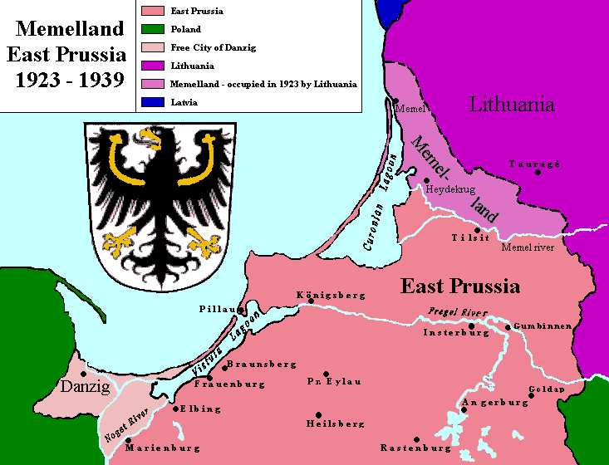
29 Jul 1252 Memele castrum or Memelburg (Memel castle), founded by Teutonic
Order in Prussia (Landmeister des Deutschen Orden in Preussen),
administered by Land-Master of Livonian Order.
4 Mar 1253 - 30 Jun 1392 The Bishop of Courland holds a third of the area, Memel is called
Nova Tremonia (or Neu-Dortmund [New Dortmund]).
25 May 1328 Livonian Order rule replaced by the Teutonic Order.
27 Sep 1422 In the Treaty of Melno (ratified 18 May 1423) the Teutonic Knights
renounced all territorial, political, and missionary claims
against the Grand Duchy of Lithuania. Samogitia is permanently
ceded to Lithuania. The border is set between Poland-Lithuania
and the Knights, with the Knights retaining Memel.
9 Apr 1525 Part of the Duchy of Prussia (which is a fief of Poland to 1657)
(see under German States to 1918).
26 Sep 1629 - Jul 1635 Swedish occupation, part of Swedish Prussia (see under Poland).
1678 - 1679 Occupied by Sweden.
18 Jan 1701 Part of the Kingdom of Prussia (and from 18 Jan 1871 Germany).
5 Jul 1757 - 6 Aug 1762 Occupied (and annexed 24 Jan 1758 - 8 Jul 1762) by Russia.
Feb 1807 - Jan 1808 Residence of the King and court of Prussia.
27 Dec 1812 - Jan 1813 Occupied by Russia.
18 Mar 1915-20/21 Mar 1915 Occupied by Russia.
10 Jan 1920 Treaty of Versailles goes into effect; Memel Territory
(Memelgebiet) is detached from Germany and put under the
administration of the Principal Allied and Associated Powers
(through the Conference of Ambassadors [France, U.K., Italy and
Japan]).
15 Feb 1920 German troops replaced by French troops; Allied administration
established.
10 Jan 1923 - 15 Jan 1923 Lithuanian "irregulars" invade and gradually occupy the territory
in support to the alternative government, set up in Heydekrug
(Šilutė) on 9 Jan 1923.
23 Jan 1923 Annexed by Lithuania (not recognized by the Allies).
16 Feb 1923 Conference of Ambassadors acquiesces conditionally to
putting Memel Territory under Lithuanian sovereignty;
Lithuanian reply is regarded on 13 Mar 1923 as acceptance.
19 Feb 1923 French troops evacuated; Allied administration de facto terminated.
15 Mar 1923 Renamed Klaipėda by Lithuania.
7 May 1923 Lithuania declares Memel autonomous.
27 Sep 1924 Memel Convention of 8 May 1924 (ratified by the Lithuanian Diet
on 30 Jul 1924) becomes effective de facto.
25 Aug 1925 With deposit of last Allied ratifications the Memel Convention goes
into effect de jure (the provisions are never fully adhered
to by Lithuania).
22 Mar 1939 Lithuania cedes Memel Territory to Germany (ratified by Lithuanian
Diet on 30 Mar 1939). Germany formally annexes Memel on 23 Mar
1939 retroactive to 22 Mar 1939. Memel is re-incorporated
into the Prussian province of East Prussia (see Prussia prov.)
10 Oct 1944 Seige by Soviet Union forces begins.
28 Jan 1945 Occupied by Soviet Union, part of Lithuanian S.S.R. as Klaipėda.
20 Jun 1950 - 28 May 1953 Klaipeda oblast, within the Lithuanian S.S.R.
First Secretary of the Klaipeda Oblast Committee of Communist Party (Bolsheviks) of Lithuania
Jun 1950 - Jun 1953 Kazimieras Frantsevich Laudis (b. 1901 - d. 1989)
(Kazimieras Laudis)
Swedish Governors
18 Sep 1629 - 1630 Alexander Leslie (b. 1585 - d. 1661)
1630 - Mar 1630 James Ramsay (b. 1589? - d. 1638)
Mar 1630 - Jan/Feb 1631 Patrick Ruthven (b. c.1573 - d. 1651)
Jan/Feb 1631 - Jul 1635 Francis Ruthven (b. 1595 - d. 1655)
(acting to 31 Aug 1632)
Swedish Commander
1678 - 1679 Henrik Henriksson Horn (b. 1618 - d. 1693)
Russian Supreme Commanders
5 Jul 1757 - 1 Aug 1757 Wilhelm von Fermor (1st time) (b. 1702 - d. 1771)
(= Villim Villimovich fon Fermor)
(acting)
1 Aug 1757 - 18 Oct 1757 Graf Stepan Fyodorovich Apraksin (b. 1702 - d. 1758)
18 Oct 1757 - 24 Jan 1758 Wilhelm von Fermor (2nd time) (s.a.)
Russian Military Commanders
27 Dec 1812 - Jan 1813 Filipp Osipovich Pauluchchi (b. 1779 - d. 1849)
(= Filippo Paulucci delle Roncole)
18 Mar 1915-20/21 Mar 1915 Aleksey Stepanovich Potapov (b. 1872 – d. af.1924)
Imperial and (Prussian) State Commissioner for the Memel Territory (Memelgebiet)
10 Jan 1920 - 15 Feb 1920 Georg Franz Wilhelm Freiherr von (b. 1863 - d. 1935)
der Wenge und Graf von Lambsdorff
High Commissioners
15 Feb 1920 - 1 May 1921 Dominique Joseph Odry (France) (b. 1865 - d. 1962) Mil
1 May 1921 - 19 Feb 1923 Jean-Gabriel Petisné (France) (b. 1881 - d. 1931)
Plenipotentiaries
19 Feb 1923 - 24 Feb 1923 Jonas (Polovinskas) Budrys (acting)(b. 1889 - d. 1964)
(Lithuania)
24 Feb 1923 - 27 Oct 1924 Antanas Smetona (Lithuania) (b. 1874 - d. 1944)
Governors (all from Lithuania)
27 Oct 1924 - 8 Nov 1925 Jonas (Polovinskas) Budrys (s.a.)
8 Nov 1925 - 1 Aug 1926 Jonas Žilius (b. 1870 - d. 1932)
1 Aug 1926 - 1 Nov 1927 Karolis Žalkauskas (b. 1892 - d. 1961)
1 Nov 1927 - 19 May 1932 Antanas Merkys (b. 1887 - d. 1953)
19 May 1932 - 25 Nov 1933 Vytautas Jonas Gylys (b. 1886 - d. 1959)
25 Nov 1933 - 5 Feb 1935 Jonas Navakas (b. 1896 - d. 1956)
5 Feb 1935 - 15 Oct 1936 Vladas Kurkauskas (b. 1895 - d. 1970)
15 Oct 1936 - 12 Dec 1938 Jurgis Kubilius (b. 1875 - d. 1961)
12 Dec 1938 - 22 Mar 1939 Viktoras Gailius (b. 1893 - d. 1956)
Transitional Commissioner for the Integration of Memelland
(Überleitungskommissar für die Eingliederung des Memellandes)
23 Mar 1939 - 30 Apr 1939 Erich Koch (b. 1896 - d. 1986) NSDAP
Fortress Commander of Memel (Festungskommandant von Memel)
Oct 1944 - 28 Jan 1945 Hans Gollnick (b. 1892 - d. 1970) Mil
Chairman of the Executive Committee of the Klaipeda Oblast Soviet
1951 - 1952 Albertas Boleslavovich Barauskas (b. 1915 - d. 2003) LKP
(Albertas Barauskas)
Presidents of the Directory (German with Lithuanian names in parentheses)
17 Feb 1920 - 6 Aug 1921 Arthur Altenberg (b. 1862 - d. 1926) Non-party
(Artūras Altenbergas)
6 Aug 1921 - 15 Jan 1923 Wilhelm Stepputat (b. 1868 - d. 1941) Non-party
(Vilius Steputaitis)
9 Jan 1923 - 15 Jan 1923 Martynas Jankus (b. 1858 - d. 1946) Lith
(chairman of the Supreme Lithuania Minor
Liberation Committee, in opposition)
15 Jan 1923 - 14 Feb 1923 Erdmann Simoneit (1st time) (b. 1888 - d. 1969) Lith
(Erdmonas Simonaitis)
15 Feb 1923 - 4 Feb 1925 Viktor Gailius (Viktoras Gailius) (s.a.) Lith
5 Feb 1925 - 15 Jan 1926 Andreas Borchert (b. 1891 - d. 1957) Lith
(Endrius Borchertas)
16 Jan 1926 - 24 Nov 1926 Erdmann Simoneit (2nd time) (s.a.) Lith
25 Nov 1926 - 4 Jan 1927 Wilhelm Falk (Vilius Falkas) (b. 1885 - d. 1970) Lith
5 Jan 1927 - 2 Dec 1927 Viktor Schwellnus Lith
(Viktoras Švelnius [Švelnys])
2 Dec 1927 - 15 Aug 1930 Otto Kadgiehn (Otas Kadgynas) (b. 1860 - d.af.1935)
16 Aug 1930 - 12 Jan 1931 Martin Reisgys (1st time) (b. 1886 - d. 1942) Lith
(Martynas Reizgys)
13 Jan 1931 - 23 Feb 1932 Otto Böttcher (Otas Betcheris) (b. 1872 - d. 1932) MVP
(deposed illegally 6 Feb 1932 and replaced
on that date by the following)
23 Feb 1932 - 1 Mar 1932 Johann Tolischus (Jonas Tolišius) (b. 1887 - d.1971/72)Lith
(acting)
2 Mar 1932 - 6 Jun 1932 Eduard Simaitis (Eduardas Simaitis)(b. 1897 - d. 1942) Lith/None
6 Jun 1932 - 28 Jun 1934 Ottomar Schreiber (b. 1889 - d. 1955) MVP
(Otomaras Šreiberis)
28 Jun 1934 - 3 Dec 1934 Martin Reisgys (2nd time) (s.a.) Lith
4 Dec 1934 - 27 Nov 1935 Georg Bruweleit (b. 1900 - d. 1995) Lith
(Jurgis Brūvelaitis)
28 Nov 1935 - 20 Jan 1939 August Baldschus (b. 1883 - d. 1952) MVP+MEL
(Augustas Baldžius)
20 Jan 1939 - 23 Mar 1939 Wilhelm "Willy" Bertuleit (b. 1900 - d. 1941) MVP+MEL
(Vilius Bertulaitas)
Party abbreviations: LA-LVP = Litauische Autonomisten und Litauische Volkspartei (Lithuanian Autonomists and Lithuanian People's Party, pro-Lithuania); Lith = Lithuanian (independent ethnic Lithuanian politicians); LKP = Lietuvos Komunistų Partijos/Kommunisticheskaya Partiya Litvy (Communist Party of Lithuania, communist, named 1940-13 Oct 1952 Lietuvos Komunistų [Bolševikų] Partijos [Communist Party (Bolsheviks) of Lithuania], 1940-20 Dec 1989 part of CPSU, 3 Oct 1918-Nov 1920 part of LBKP, 1940-7 Dec 1989 state party, Nov 1920-8 Dec 1990, renamed LDDP); MAP = Memelländische Arbeiterpartei (Memelland Workers' Party, communist, 1925-1935); MEL = Memelländische Einheitsliste (Memelland Unity List, German coalition of MAP, MVP, and SPM, 1935-1939); MLP = Memelländische Landwirtschaftspartei (Memelland Farmers' Party, agrarian, centrist, 1925-1934, banned 1934); MVP = Memelländische Volkspartei (Memelland People's Party, German nationalist, 1925-1935); NSDAP = Nationalsozialistische Deutsche Arbeiterpartei (National Socialist German Workers' Party, German nationalist, Nazi fascist, 1920-1945); SPM = Sozialdemokratische Partei des Memelgebietes (Social Democratic Party of Memel Region, social-democratic, 1925-1935); Mil =
German Administrative Area of the Commander-in-Chief of the Eastern Front 1915 - 1918
6 Jul 1915 Administrative Area of the Commander-in-Chief of the Eastern Front
(Oberbefehlshabers der gesamten Deutschen Streitkräfte im Osten),
in short Ober-Ost, established (not formally recognized by the
German government until 4 Nov 1915) as a German supreme military
administration over occupied north-western part of the Russian
Empire (by late 1918 covers present-day Lithuania, Latvia,
Estonia and parts of Poland [Suwałki, Białystok] and parts
Russia [Pskov]). Seat of administration in Kaunas, Lithuania.
11 Nov 1918 By the Armistice at Compiegne the German troops to be withdrawn
from the East (fixed time not given); effective German
administration gradually collapses.
26 Dec 1918 Ober-Ost abolished. Headquarters of commander-in-chief moved
to Königsberg in East Prussia on 20 Dec 1918.
21 Jan 1919 Office of commander-in-chief of the Eastern Front abolished.
Commanders-in-Chief of All German Armed Forces in the East ("Ober-Ost")
1 Nov 1914 - 29 Aug 1916 Paul Ludwig Hans Anton von (b. 1847 - d. 1934) Mil
Beneckendorff und von Hindenburg
29 Aug 1916 - 26 Dec 1918 Leopold Maximilian Joseph Maria (b. 1846 - d. 1930) Mil
Prinz von Bayern
Lithuanian Soviet Socialist Republic
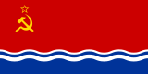 |  |  | 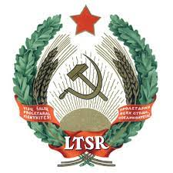
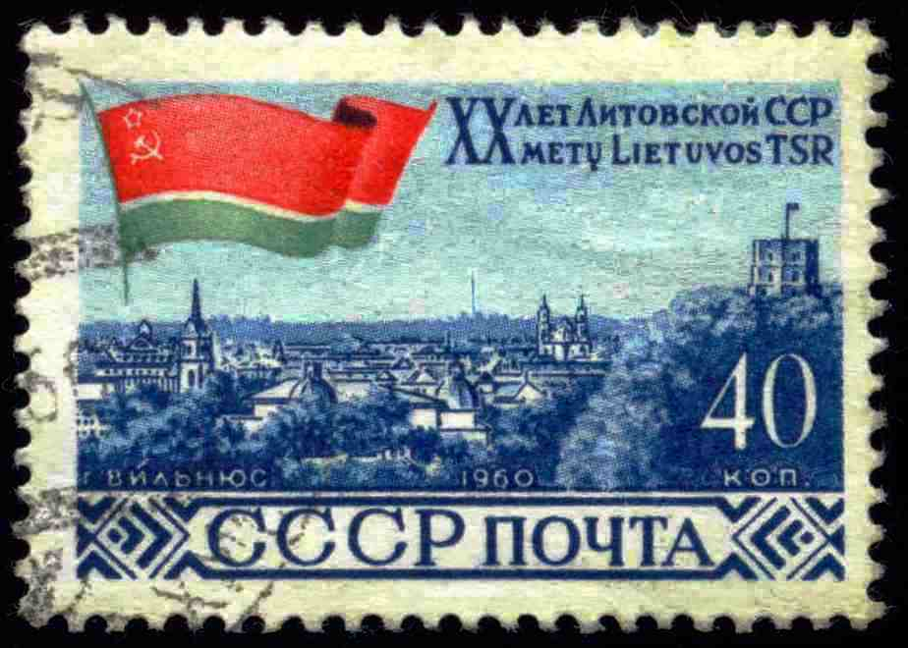 |  |  | 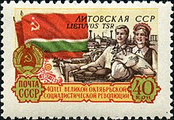
21 Jul 1940 Lithuanian Soviet Socialist Republic (Lietuvos Tarybų Socialistinė
Respublika/Litovskaya Sovetskaya Socialisticheskaya Respublika).
3 Aug 1940 Accession to the Soviet Union (see under Russia).
24 Jun 1941 - 13 Jul 1944 German occupation of Vilnius (eventually all of Lithuania),
from 25 Jul 1941 part of Reichskommissariat of Ostland
(see under Latvia).
18 Nov 1988 Lithuanian made the only official language.
18 May 1989 Declaration of state sovereignty.
11 Mar 1990 Republic of Lithuania (Lietuvos Respublika).
Note: Lithuanian names with Russian in parentheses
First Secretaries of the Central Committee of the Lithuanian Communist Party (LKP)
(1940 - 13 Oct 1952, Lithuanian Communist [Bolshevik] Party)
25 Aug 1940 - 21 Jan 1974 Antanas Sniečkus (b. 1903 - d. 1974)
(Antanas Yuozovich Snechkuss)
(in Russian SFSR exile 24 Jun 1941 - Oct 1944)
21 Jan 1974 - 18 Feb 1974 Valerijus Charazovas (acting) (b. 1918 - d. 2013)
(Valeriy Innokentyevich Kharazov)
18 Feb 1974 - 14 Nov 1987 Petras Griškevičius (b. 1924 - d. 1987)
(Pyatras Pyatrovich Grishkyavichyus)
14 Nov 1987 - 1 Dec 1987 Nikolajus Mitkinas (acting) (b. 1929 - d. 1998)
(Nikolay Andreyevich Mitkin)
1 Dec 1987 - 20 Oct 1988 Ringaudas-Bronislavas Songaila (b. 1929 - d. 2019)
(Ringaudas-Bronislovas Ignovich Songayla)
20 Oct 1988 - 7 Dec 1989 Algirdas Mykolas Brazauskas (b. 1932 - d. 2010)
(Algirdas-Mikolas Kazevich Brazauskas)
(continues until 8 Dec 1990)
23 Dec 1989 - 24 Aug 1991 Mykolas Burokevičius (b. 1927 - d. 2016)
(Mykolas Martinovich Burokyavichyus [Burokyavichus])
(of separate Communist Party of Lithuania-CPSU)
("leading role" of the party abolished 7 Dec 1989)
Chairmen of the Presidium of the Supreme Soviet
25 Aug 1940 - 15 Apr 1967 Justas Paleckis (b. 1899 - d. 1980) LKP
(Yustas Ignovich Paletskis)
(in Russian SFSR exile 24 Jun 1941 - 1 Aug 1944)
15 Apr 1967 - 24 Dec 1975 Motiejus Šumauskas (b. 1905 - d. 1982) LKP
(Moteyus Yuozovich Shumauskas)
24 Dec 1975 - 18 Nov 1985 Antanas Barkauskas (b. 1917 - d. 2008) LKP
(Antanas Stasevich Barkauskas)
18 Nov 1985 - 7 Dec 1987 Ringaudas-Bronislavas Songaila (s.a.) LKP
7 Dec 1987 - 15 Jan 1990 Vytautas Astrauskas (b. 1930 - d. 2017) LKP
(Vytautas Stasevich Astrauskas)
15 Jan 1990 - 11 Mar 1990 Algirdas Mykolas Brazauskas (s.a.) LKP
Chairman of the Council of People's Commissars
25 Aug 1940 - 2 Apr 1946 Mečislovas Gedvilas (b. 1901 - d. 1981) LKP
(Mechislovas Aleksandrovich Gedvilas)
(in Russian SFSR exile 24 Jun 1941 - 13 Jul 1944)
Chairmen of the Council of Ministers
2 Apr 1946 - 16 Jan 1956 Mečislovas Gedvilas (s.a.) LKP
16 Jan 1956 - 15 Apr 1967 Motiejus Šumauskas (s.a.) LKP
15 Apr 1967 - 16 Jan 1981 Juozas Maniušis (b. 1910 - d. 1987) LKP
(Iosif Antonovich Manyushis)
16 Jan 1981 - 18 Nov 1985 Ringaudas-Bronislavas Songaila (s.a.) LKP
18 Nov 1985 - 11 Mar 1990 Vytautas Sakalauskas (b. 1933 - d. 2001) LKP
(Vytautas Vladovich Sakalauskas)
Pro-Soviet Resistance to German Occupation 1942-1944
Note: Soviet resistance groups in Lithuania were united in 1942 in a separate command directly subordinated to the Central Staff of the Partisan Units in Moscow.
Chief of Staff of the Lithuanian Partisan Units
26 Nov 1942 - 1944 Antanas Sniečkus (s.a.) LKP
Party abbreviations: LDDP = Lietuvos Demokratine Darbo Partija (Democratic Labor Party of Lithuania, democratic socialist former LKP, 8 Dec 1990-27 Jan 2001, renamed LSDP); LKP = Lietuvos Komunistų Partijos/Kommunisticheskaya Partiya Litvy (Communist Party of Lithuania, communist, named 1940-13 Oct 1952 Lietuvos Komunistų [Bolševikų] Partijos [Communist Party (Bolsheviks) of Lithuania], 1940-20 Dec 1989 part of CPSU, 3 Oct 1918-Nov 1920 part of LBKP, 1940-7 Dec 1989 state party, Nov 1920-8 Dec 1990, renamed LDDP)

Ministries, etc.

Key ministries

Foreign Affairs
Ministers
24 Mar 1990 - 12 Dec 1992 Algirdas Saudargas (1st time) (b. 1948)
12 Dec 1992 - 4 Dec 1996 Povilas Gylys (b. 1948)
4 Dec 1996 - 30 Oct 2000 Algirdas Saudargas (2nd time) (s.a.)
30 Oct 2000 - 18 Jul 2006 Antanas Valionis (b. 1950)
18 Jul 2006 - 9 Dec 2008 Petras Vaitiekunas (b. 1953)
9 Dec 2008 - 26 Jan 2010 Vygaudas Usackas (b. 1964)
26 Jan 2010 - 11 Feb 2010 Rasa Jukneviciene (f) (acting) (b. 1958)
11 Feb 2010 - 13 Dec 2012 Audronius Azubalis (b. 1958)
13 Dec 2012 - 11 Dec 2020 Linas Linkevicius (b. 1961)
11 Dec 2020 - Gabrielius Landsbergis (b. 1982)

Defense
Ministers
13 Jan 1991 - 28 Oct 1993 Audrius Butkevicius (b. 1960)
28 Oct 1993 - 4 Dec 1996 Linas Linkevicius (1st time) (b. 1961)
4 Dec 1996 - 30 Oct 2000 Ceslovas Stankevicius (b. 1937)
30 Oct 2000 - 7 Dec 2004 Linas Linkevicius (2nd time) (s.a.)
7 Dec 2004 - 18 Jul 2006 Gediminas Kirkilas (b. 1951)
18 Jul 2006 - 9 Dec 2008 Juozas Olekas (1st time) (b. 1955)
9 Dec 2008 - 13 Dec 2012 Rasa Jukneviciene (f) (b. 1958)
13 Dec 2012 - 13 Dec 2016 Juozas Olekas (2nd time) (s.a.)
13 Dec 2016 - 11 Dec 2020 Raimundas Karoblis (b. 1968)
11 Dec 2020 - Arvydas Anusauskas (b. 1963)

Interior
Ministers
23 Mar 1990 - 13 Jan 1991 Marijonas Misiukonis (b. 1939)
13 Jan 1991 - 12 Dec 1992 Petras Valiukas (b. 1948 - d. 1993)
12 Dec 1992 - 23 Feb 1996 Romasis Vaitekunas (b. 1943)
23 Feb 1996 - 4 Dec 1996 Virgilijus Bulovas (1st time) (b. 1939)
4 Dec 1996 - 21 May 1998 Vidmantas Ziemelis (b. 1950)
21 May 1998 - 22 May 1998 Vytautas Pakalniskis (acting) (b. 1944)
22 May 1998 - 1 Jun 1999 Stasys Sedbaras (b. 1958)
1 Jun 1999 - 30 Oct 2000 Ceslovas Blazys (b. 1943)
30 Oct 2000 - 12 Jul 2001 Vytautas Markevicius (b. 1962)
12 Jul 2001 - 13 May 2003 Juozas Bernatonis (b. 1953)
13 May 2003 - 7 Dec 2004 Virgilijus Bulovas (2nd time) (s.a.)
7 Dec 2004 - 18 Jul 2006 Gintaras Furmanavicius (b. 1961)
18 Jul 2006 - 10 Dec 2007 Raimondas Sukys (1st time) (b. 1966)
10 Dec 2007 - 18 Dec 2007 Algirdas Butkevicius (acting) (b. 1958)
18 Dec 2007 - 9 Dec 2008 Regimantas Ciupaila (b. 1956)
9 Dec 2008 - 26 Mar 2012 Raimundas Palaitis (b. 1957)
26 Mar 2012 - 16 Apr 2012 Raimondas Sukys (2nd time) (s.a.)
(acting)
16 Apr 2012 - 13 Dec 2012 Arturas Melianas (b. 1964)
13 Dec 2012 - 11 Nov 2014 Dailis Barakauskas (b. 1952)
11 Nov 2014 - 14 Apr 2016 Saulius Skvernelis (b. 1970)
14 Apr 2016 - 13 Dec 2016 Tomas Zilinskas (b. 1977)
13 Dec 2016 - 7 Aug 2019 Eimutis Misiunas (b. 1973)
7 Aug 2019 - 11 Dec 2020 Rita Tamasuniene (f) (b. 1973)
11 Dec 2020 - Agne Bilotaite (f) (b. 1982)

Finance
Ministers
23 Mar 1990 - 13 Jan 1991 Romualdas Sikorskis (b. 1926 - d. 1997)
13 Jan 1991 - 30 Jul 1992 Elvyra Kuneviciene (f) (b. 1939)
30 Jul 1992 - 12 Dec 1992 Audrius Misevicius (b. 1959)
12 Dec 1992 - 10 Feb 1995 Eduardas Vilkelis (b. 1953 - d. 2023)
10 Feb 1995 - 23 Feb 1996 Reinoldijus Sarkinas (b. 1946)
23 Feb 1996 - 4 Dec 1996 Algimantas Krizinauskas (b. 1958)
4 Dec 1996 - 19 Feb 1997 Rolandas Matiliauskas (b. 1968)
19 Feb 1997 - 1 Jun 1999 Algirdas Semeta (1st time) (b. 1962)
1 Jun 1999 - 3 Nov 1999 Jonas Lionginas (1st time) (b. 1956)
3 Nov 1999 - 30 Oct 2000 Vytautas Dudenas (b. 1937)
30 Oct 2000 - 12 Jul 2001 Jonas Lionginas (2nd time) (s.a.)
12 Jul 2001 - 1 May 2004 Dalia Grybauskaite (f) (b. 1956)
1 May 2004 - 14 May 2005 Algirdas Butkevicius (b. 1958)
14 May 2005 - 17 May 2007 Zigmantas Balcytis (b. 1953)
17 May 2007 - 9 Dec 2008 Rimantas Sadzius (1st time) (b. 1960)
9 Dec 2008 - 30 Jun 2009 Algirdas Semeta (2nd time) (s.a.)
7 Jul 2009 - 13 Dec 2012 Ingrida Simonyte (f) (b. 1974)
13 Dec 2012 - 23 Jun 2016 Rimantas Sadzius (2nd time) (s.a.)
23 Jun 2016 - 13 Dec 2016 Rasa Budbergyte (f) (b. 1960)
13 Dec 2016 - 11 Dec 2020 Vilius Sapoka (b. 1978)
11 Dec 2020 - Gintare Skaiste (f) (b. 1981)

Justice
Ministers
23 Mar 1990 - 13 Jan 1991 Pranas Kuris (b. 1938)
13 Jan 1991 - 30 Jul 1992 Vytautas Pakalniskis (1st time) (b. 1944)
30 Jul 1992 - 12 Dec 1992 Zenonas Juknevicius (acting) (b. 1949)
12 Dec 1992 - 23 Apr 1996 Jonas Prapiestis (b. 1952)
23 Apr 1996 - 4 Dec 1996 Albertas Valys (b. 1953)
4 Dec 1996 - 1 Jun 1999 Vytautas Pakalniskis (2nd time) (s.a.)
1 Jun 1999 - 30 Oct 2000 Gintaras Balciunas (b. 1964)
30 Oct 2000 - 12 Jul 2001 Gintautas Bartkus (b. 1966)
12 Jul 2001 - 7 Dec 2004 Vytautas Markevicius (b. 1962)
7 Dec 2004 - 18 Jul 2006 Gintautas Buzinskas (b. 1960)
18 Jul 2006 - 9 Dec 2008 Petras Baguska (b. 1941)
9 Dec 2008 - 13 Dec 2012 Remigijus Simasius (b. 1974)
13 Dec 2012 - 13 Dec 2016 Juozas Bernatonis (b. 1953)
13 Dec 2016 - 9 Mar 2018 Milda Vainiute (f) (b. 1962)
9 Mar 2018 - 14 May 2018 Eimutis Misiunas (acting) (b. 1973)
14 May 2018 - 11 Dec 2020 Elvinas Jankevicius (b. 1976)
11 Dec 2020 - Evelina Dobrovolska (f) (b. 1988)

Parliament

Supreme Assembly
Chairman
11 Mar 1990 - 25 Nov 1992 Vytautas Landsbergis (b. 1932)

Seimas
Speakers
25 Nov 1992 - 25 Nov 1996 Ceslovas Jursenas (1st time) (b. 1938)
(acting to 25 Feb 1993)
25 Nov 1996 - 19 Oct 2000 Vytautas Landsbergis (s.a.)
19 Oct 2000 - 6 Apr 2004 Arturas Paulauskas (1st time) (b. 1953)
6 Apr 2004 - 12 Jul 2004 Ceslovas Jursenas (2nd time) (s.a.)
(acting)
12 Jul 2004 - 12 Apr 2006 Arturas Paulauskas (2nd time) (s.a.)
13 Apr 2006 - 1 Apr 2008 Viktoras Muntianas (b. 1951)
1 Apr 2008 - 17 Nov 2008 Ceslovas Jursenas (3rd time) (s.a.)
17 Nov 2008 - 15 Sep 2009 Arunas Valinskas (b. 1966)
15 Sep 2009 - 16 Nov 2012 Irena Degutiene (f) (b. 1949)
(acting to 17 Sep 2009)
16 Nov 2012 - 3 Oct 2013 Vydas Gedvilas (b. 1959)
3 Oct 2013 - 14 Nov 2016 Loreta Grauziniene (f) (b. 1963)
14 Nov 2016 - 13 Nov 2020 Viktoras Pranckietis (b. 1958)
13 Nov 2020 - Viktorija Cmilyte-Nielsen (f) (b. 1983)

INCLUDEPICTURE "http://t0.gstatic.com/images?q=tbn:ANd9GcTDT1jpfS6n_Y4NmsXFnf0dV2uAk854tEHeOSaIXPxUCt7qxHu5xaSaZA" \* MERGEFORMATINET INCLUDEPICTURE "http://t0.gstatic.com/images?q=tbn:ANd9GcTDT1jpfS6n_Y4NmsXFnf0dV2uAk854tEHeOSaIXPxUCt7qxHu5xaSaZA" \* MERGEFORMATINET INCLUDEPICTURE "http://t0.gstatic.com/images?q=tbn:ANd9GcTDT1jpfS6n_Y4NmsXFnf0dV2uAk854tEHeOSaIXPxUCt7qxHu5xaSaZA" \* MERGEFORMATINET INCLUDEPICTURE "http://t0.gstatic.com/images?q=tbn:ANd9GcTDT1jpfS6n_Y4NmsXFnf0dV2uAk854tEHeOSaIXPxUCt7qxHu5xaSaZA" \* MERGEFORMATINET INCLUDEPICTURE "http://t0.gstatic.com/images?q=tbn:ANd9GcTDT1jpfS6n_Y4NmsXFnf0dV2uAk854tEHeOSaIXPxUCt7qxHu5xaSaZA" \* MERGEFORMATINET INCLUDEPICTURE "http://t0.gstatic.com/images?q=tbn:ANd9GcTDT1jpfS6n_Y4NmsXFnf0dV2uAk854tEHeOSaIXPxUCt7qxHu5xaSaZA" \* MERGEFORMATINET INCLUDEPICTURE "http://t0.gstatic.com/images?q=tbn:ANd9GcTDT1jpfS6n_Y4NmsXFnf0dV2uAk854tEHeOSaIXPxUCt7qxHu5xaSaZA" \* MERGEFORMATINET INCLUDEPICTURE "http://t0.gstatic.com/images?q=tbn:ANd9GcTDT1jpfS6n_Y4NmsXFnf0dV2uAk854tEHeOSaIXPxUCt7qxHu5xaSaZA" \* MERGEFORMATINET INCLUDEPICTURE "http://t0.gstatic.com/images?q=tbn:ANd9GcTDT1jpfS6n_Y4NmsXFnf0dV2uAk854tEHeOSaIXPxUCt7qxHu5xaSaZA" \* MERGEFORMATINET INCLUDEPICTURE "http://t0.gstatic.com/images?q=tbn:ANd9GcTDT1jpfS6n_Y4NmsXFnf0dV2uAk854tEHeOSaIXPxUCt7qxHu5xaSaZA" \* MERGEFORMATINET INCLUDEPICTURE "http://t0.gstatic.com/images?q=tbn:ANd9GcTDT1jpfS6n_Y4NmsXFnf0dV2uAk854tEHeOSaIXPxUCt7qxHu5xaSaZA" \* MERGEFORMATINET INCLUDEPICTURE "http://t0.gstatic.com/images?q=tbn:ANd9GcTDT1jpfS6n_Y4NmsXFnf0dV2uAk854tEHeOSaIXPxUCt7qxHu5xaSaZA" \* MERGEFORMATINET INCLUDEPICTURE "http://t0.gstatic.com/images?q=tbn:ANd9GcTDT1jpfS6n_Y4NmsXFnf0dV2uAk854tEHeOSaIXPxUCt7qxHu5xaSaZA" \* MERGEFORMATINET INCLUDEPICTURE "http://t0.gstatic.com/images?q=tbn:ANd9GcTDT1jpfS6n_Y4NmsXFnf0dV2uAk854tEHeOSaIXPxUCt7qxHu5xaSaZA" \* MERGEFORMATINET INCLUDEPICTURE "http://t0.gstatic.com/images?q=tbn:ANd9GcTDT1jpfS6n_Y4NmsXFnf0dV2uAk854tEHeOSaIXPxUCt7qxHu5xaSaZA" \* MERGEFORMATINET INCLUDEPICTURE "http://t0.gstatic.com/images?q=tbn:ANd9GcTDT1jpfS6n_Y4NmsXFnf0dV2uAk854tEHeOSaIXPxUCt7qxHu5xaSaZA" \* MERGEFORMATINET INCLUDEPICTURE "http://t0.gstatic.com/images?q=tbn:ANd9GcTDT1jpfS6n_Y4NmsXFnf0dV2uAk854tEHeOSaIXPxUCt7qxHu5xaSaZA" \* MERGEFORMATINET INCLUDEPICTURE "http://t0.gstatic.com/images?q=tbn:ANd9GcTDT1jpfS6n_Y4NmsXFnf0dV2uAk854tEHeOSaIXPxUCt7qxHu5xaSaZA" \* MERGEFORMATINET INCLUDEPICTURE "http://t0.gstatic.com/images?q=tbn:ANd9GcTDT1jpfS6n_Y4NmsXFnf0dV2uAk854tEHeOSaIXPxUCt7qxHu5xaSaZA" \* MERGEFORMATINET INCLUDEPICTURE "http://t0.gstatic.com/images?q=tbn:ANd9GcTDT1jpfS6n_Y4NmsXFnf0dV2uAk854tEHeOSaIXPxUCt7qxHu5xaSaZA" \* MERGEFORMATINET INCLUDEPICTURE "http://t0.gstatic.com/images?q=tbn:ANd9GcTDT1jpfS6n_Y4NmsXFnf0dV2uAk854tEHeOSaIXPxUCt7qxHu5xaSaZA" \* MERGEFORMATINET INCLUDEPICTURE "http://t0.gstatic.com/images?q=tbn:ANd9GcTDT1jpfS6n_Y4NmsXFnf0dV2uAk854tEHeOSaIXPxUCt7qxHu5xaSaZA" \* MERGEFORMATINET INCLUDEPICTURE "http://t0.gstatic.com/images?q=tbn:ANd9GcTDT1jpfS6n_Y4NmsXFnf0dV2uAk854tEHeOSaIXPxUCt7qxHu5xaSaZA" \* MERGEFORMATINET INCLUDEPICTURE "http://t0.gstatic.com/images?q=tbn:ANd9GcTDT1jpfS6n_Y4NmsXFnf0dV2uAk854tEHeOSaIXPxUCt7qxHu5xaSaZA" \* MERGEFORMATINET INCLUDEPICTURE "http://t0.gstatic.com/images?q=tbn:ANd9GcTDT1jpfS6n_Y4NmsXFnf0dV2uAk854tEHeOSaIXPxUCt7qxHu5xaSaZA" \* MERGEFORMATINET INCLUDEPICTURE "http://t0.gstatic.com/images?q=tbn:ANd9GcTDT1jpfS6n_Y4NmsXFnf0dV2uAk854tEHeOSaIXPxUCt7qxHu5xaSaZA" \* MERGEFORMATINET INCLUDEPICTURE "http://t0.gstatic.com/images?q=tbn:ANd9GcTDT1jpfS6n_Y4NmsXFnf0dV2uAk854tEHeOSaIXPxUCt7qxHu5xaSaZA" \* MERGEFORMATINET INCLUDEPICTURE "http://t0.gstatic.com/images?q=tbn:ANd9GcTDT1jpfS6n_Y4NmsXFnf0dV2uAk854tEHeOSaIXPxUCt7qxHu5xaSaZA" \* MERGEFORMATINET INCLUDEPICTURE "http://t0.gstatic.com/images?q=tbn:ANd9GcTDT1jpfS6n_Y4NmsXFnf0dV2uAk854tEHeOSaIXPxUCt7qxHu5xaSaZA" \* MERGEFORMATINET INCLUDEPICTURE "http://t0.gstatic.com/images?q=tbn:ANd9GcTDT1jpfS6n_Y4NmsXFnf0dV2uAk854tEHeOSaIXPxUCt7qxHu5xaSaZA" \* MERGEFORMATINET INCLUDEPICTURE "http://t0.gstatic.com/images?q=tbn:ANd9GcTDT1jpfS6n_Y4NmsXFnf0dV2uAk854tEHeOSaIXPxUCt7qxHu5xaSaZA" \* MERGEFORMATINET INCLUDEPICTURE "http://t0.gstatic.com/images?q=tbn:ANd9GcTDT1jpfS6n_Y4NmsXFnf0dV2uAk854tEHeOSaIXPxUCt7qxHu5xaSaZA" \* MERGEFORMATINET INCLUDEPICTURE "http://t0.gstatic.com/images?q=tbn:ANd9GcTDT1jpfS6n_Y4NmsXFnf0dV2uAk854tEHeOSaIXPxUCt7qxHu5xaSaZA" \* MERGEFORMATINET INCLUDEPICTURE "http://t0.gstatic.com/images?q=tbn:ANd9GcTDT1jpfS6n_Y4NmsXFnf0dV2uAk854tEHeOSaIXPxUCt7qxHu5xaSaZA" \* MERGEFORMATINET INCLUDEPICTURE "http://t0.gstatic.com/images?q=tbn:ANd9GcTDT1jpfS6n_Y4NmsXFnf0dV2uAk854tEHeOSaIXPxUCt7qxHu5xaSaZA" \* MERGEFORMATINET INCLUDEPICTURE "http://t0.gstatic.com/images?q=tbn:ANd9GcTDT1jpfS6n_Y4NmsXFnf0dV2uAk854tEHeOSaIXPxUCt7qxHu5xaSaZA" \* MERGEFORMATINET INCLUDEPICTURE "http://t0.gstatic.com/images?q=tbn:ANd9GcTDT1jpfS6n_Y4NmsXFnf0dV2uAk854tEHeOSaIXPxUCt7qxHu5xaSaZA" \* MERGEFORMATINET INCLUDEPICTURE "http://t0.gstatic.com/images?q=tbn:ANd9GcTDT1jpfS6n_Y4NmsXFnf0dV2uAk854tEHeOSaIXPxUCt7qxHu5xaSaZA" \* MERGEFORMATINET INCLUDEPICTURE "http://t0.gstatic.com/images?q=tbn:ANd9GcTDT1jpfS6n_Y4NmsXFnf0dV2uAk854tEHeOSaIXPxUCt7qxHu5xaSaZA" \* MERGEFORMATINET INCLUDEPICTURE "http://t0.gstatic.com/images?q=tbn:ANd9GcTDT1jpfS6n_Y4NmsXFnf0dV2uAk854tEHeOSaIXPxUCt7qxHu5xaSaZA" \* MERGEFORMATINET INCLUDEPICTURE "http://t0.gstatic.com/images?q=tbn:ANd9GcTDT1jpfS6n_Y4NmsXFnf0dV2uAk854tEHeOSaIXPxUCt7qxHu5xaSaZA" \* MERGEFORMATINET INCLUDEPICTURE "http://t0.gstatic.com/images?q=tbn:ANd9GcTDT1jpfS6n_Y4NmsXFnf0dV2uAk854tEHeOSaIXPxUCt7qxHu5xaSaZA" \* MERGEFORMATINET INCLUDEPICTURE "http://t0.gstatic.com/images?q=tbn:ANd9GcTDT1jpfS6n_Y4NmsXFnf0dV2uAk854tEHeOSaIXPxUCt7qxHu5xaSaZA" \* MERGEFORMATINET INCLUDEPICTURE "http://t0.gstatic.com/images?q=tbn:ANd9GcTDT1jpfS6n_Y4NmsXFnf0dV2uAk854tEHeOSaIXPxUCt7qxHu5xaSaZA" \* MERGEFORMATINET INCLUDEPICTURE "http://t0.gstatic.com/images?q=tbn:ANd9GcTDT1jpfS6n_Y4NmsXFnf0dV2uAk854tEHeOSaIXPxUCt7qxHu5xaSaZA" \* MERGEFORMATINET INCLUDEPICTURE "http://t0.gstatic.com/images?q=tbn:ANd9GcTDT1jpfS6n_Y4NmsXFnf0dV2uAk854tEHeOSaIXPxUCt7qxHu5xaSaZA" \* MERGEFORMATINET INCLUDEPICTURE "http://t0.gstatic.com/images?q=tbn:ANd9GcTDT1jpfS6n_Y4NmsXFnf0dV2uAk854tEHeOSaIXPxUCt7qxHu5xaSaZA" \* MERGEFORMATINET INCLUDEPICTURE "http://t0.gstatic.com/images?q=tbn:ANd9GcTDT1jpfS6n_Y4NmsXFnf0dV2uAk854tEHeOSaIXPxUCt7qxHu5xaSaZA" \* MERGEFORMATINET INCLUDEPICTURE "http://t0.gstatic.com/images?q=tbn:ANd9GcTDT1jpfS6n_Y4NmsXFnf0dV2uAk854tEHeOSaIXPxUCt7qxHu5xaSaZA" \* MERGEFORMATINET INCLUDEPICTURE "http://t0.gstatic.com/images?q=tbn:ANd9GcTDT1jpfS6n_Y4NmsXFnf0dV2uAk854tEHeOSaIXPxUCt7qxHu5xaSaZA" \* MERGEFORMATINET INCLUDEPICTURE "http://t0.gstatic.com/images?q=tbn:ANd9GcTDT1jpfS6n_Y4NmsXFnf0dV2uAk854tEHeOSaIXPxUCt7qxHu5xaSaZA" \* MERGEFORMATINET

Compiler FLN

